# **INTRODUCTION**

## Overview

Gadget Galaxy is a mobile application providing an all-in-one shopping experience for electronic gadgets. The primary objective of this part 2 is to enhance the database infrastructure of this electronics e-commerce platform. This involves designing a flexible No SQL data model, migrating existing data, and implementing advanced querying and indexing mechanisms to optimize search and retrieval processes. Additionally, **Gadget Galaxy** aims to ensure data consistency, integrity, and high scalability to support the platform's operational requirements. By using the capabilities of a NoSQL database, we aim to create a scalable, and efficient system that meets the evolving demands of the online marketplace

## Application Business Requirements and Functionality

### Functional Requirements

1. Data Modeling: Choosing and designing a comprehensive data model to accommodate the diverse and hierarchical data associated with electronics products, user profiles, orders, and inventory.
2. Data Migration: Efficiently migrating relevant data from an existing MySQL database to the chosen NoSQL database, ensuring minimal downtime and data integrity.
3. Product Listings and Search Optimization: Modifying the platform to utilize the NoSQL database for product listings and searches, implementing indexing and querying mechanisms for efficient and accurate search results.
4. Scalability: Exploring and implementing strategies to scale the database system as the dataset and user base grow.

### Non-Functional Requirements

1. Database Selection and Justification: Choosing the appropriate NoSQL database system, such as MongoDB, based on the specific requirements of the e-commerce platform.
2. Scalability and Performance Testing: Conducting performance tests to assess the database's scalability and responsiveness.
3. Analytical Queries: Building queries to demonstrate the advantages of the NoSQL approach over traditional relational database systems.

# **INSTALLATION OF MONGODB**

We are using Mac OS for this project. For installing MongoDB on mac os , we used Homebrew and we followed these steps[7].

### MongoDB Community Edition

1. **Tap the MongoDB Homebrew Tap**:

brew tap mongodb/brew

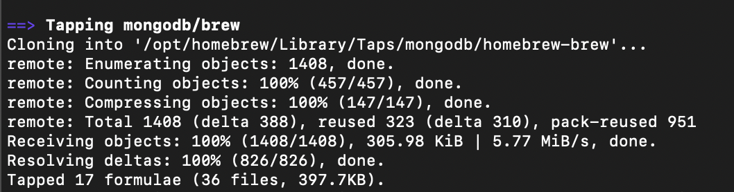

1. **Install MongoDB Community Edition**:

brew install mongodb/brew/mongodb-community

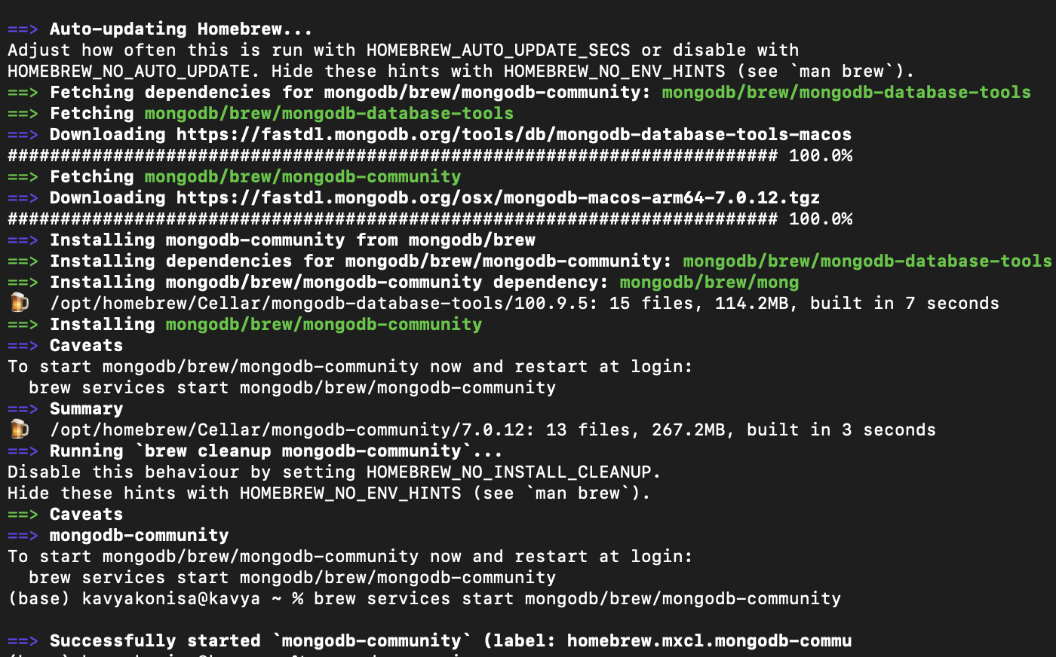

1. **Start MongoDB service**:

brew services start mongodb/brew/mongodb-community

1. **Verify Installation**: Check if MongoDB is installed correctly:

mongod –version

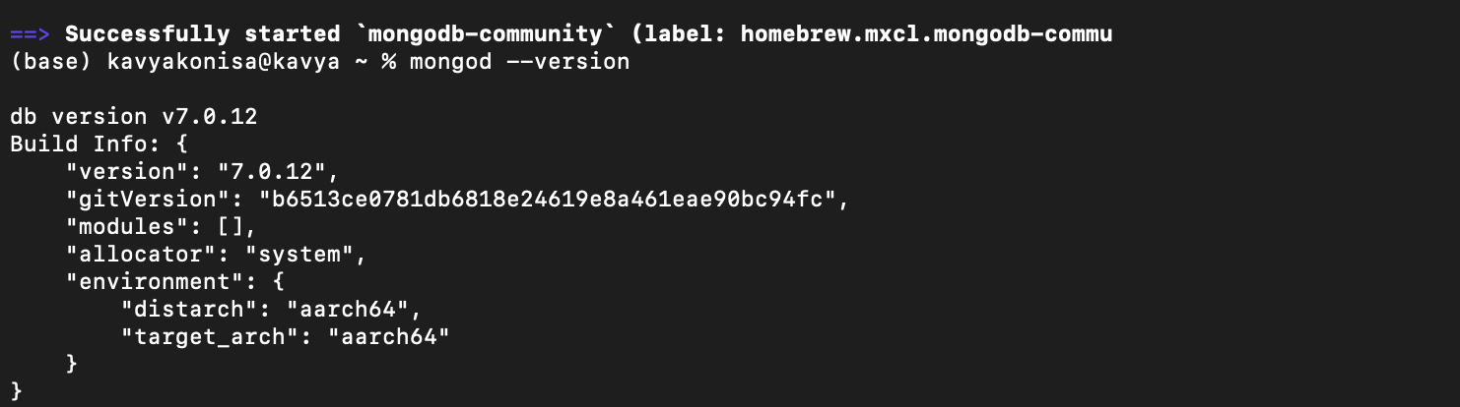

### MongoDB Shell

MongoDB Shell is a command-line interface that offers greater flexibility and control over MongoDB operations. It is ideal for developers and database administrators who need to execute complex queries, perform administrative tasks, and automate workflows using scripts. The shell allows for precise, text-based interaction with the database, which can be faster and more efficient for experienced users.

To install MongoDB Shell (mongosh), follow these steps:

1. **Install MongoDB Shell**:

brew install mongosh

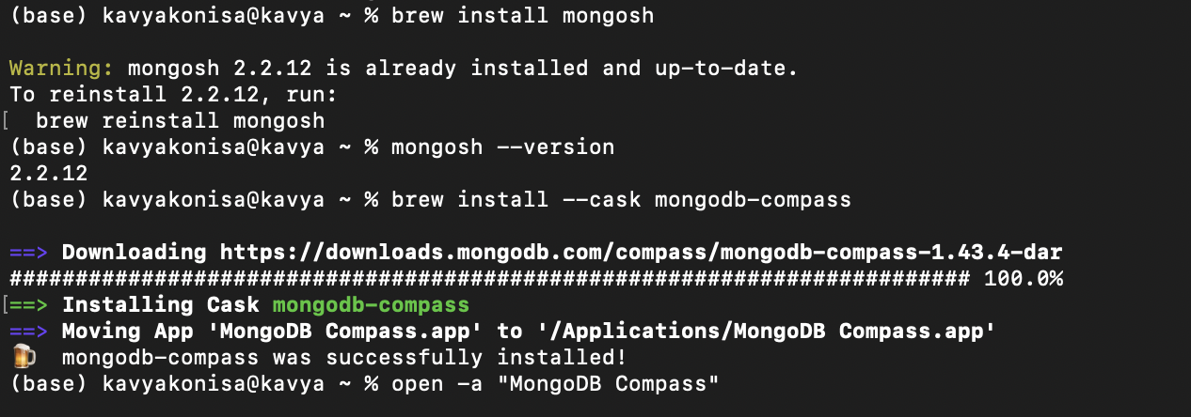

1. **Verify Installation**:

mongosh –version



### MongoDB Compass

MongoDB Compass provides a graphical interface, making it easy for users to visualize, explore, and manipulate their MongoDB data without writing any code. It is particularly useful for those who prefer a more visual approach to database management and for performing tasks such as data analysis, schema visualization, and query execution through a point-and-click interface.

To install MongoDB Compass , follow these steps:

1. **Install MongoDB Compass**:

brew install --cask mongodb-compass

1. **Open MongoDB Compass**: You can open it from your Applications folder or by typing:

open -a "MongoDB Compass"

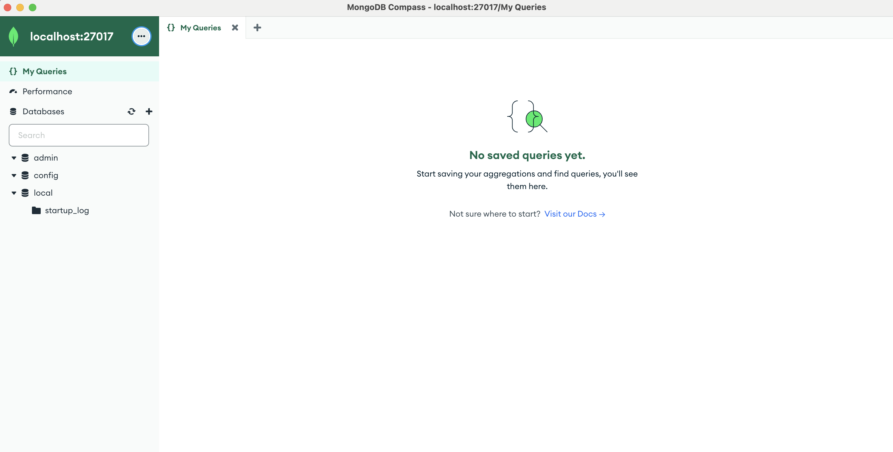

# **4.CONNECTING OF MONGODB**

For connecting to MongoDB , we can go to compass and click connect or go to command prompt and type mongosh.

1. MongoDB shell

**Mongosh -** It connects to this server

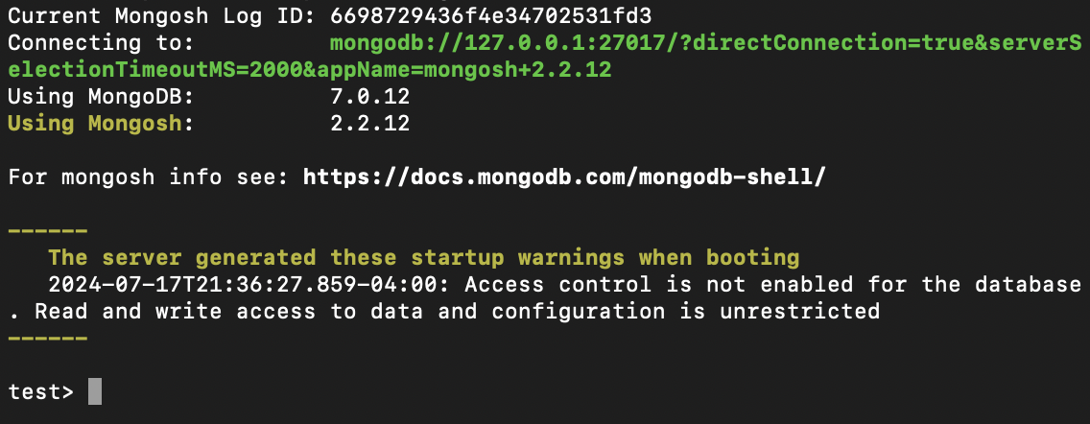

1. MongoDB Compass

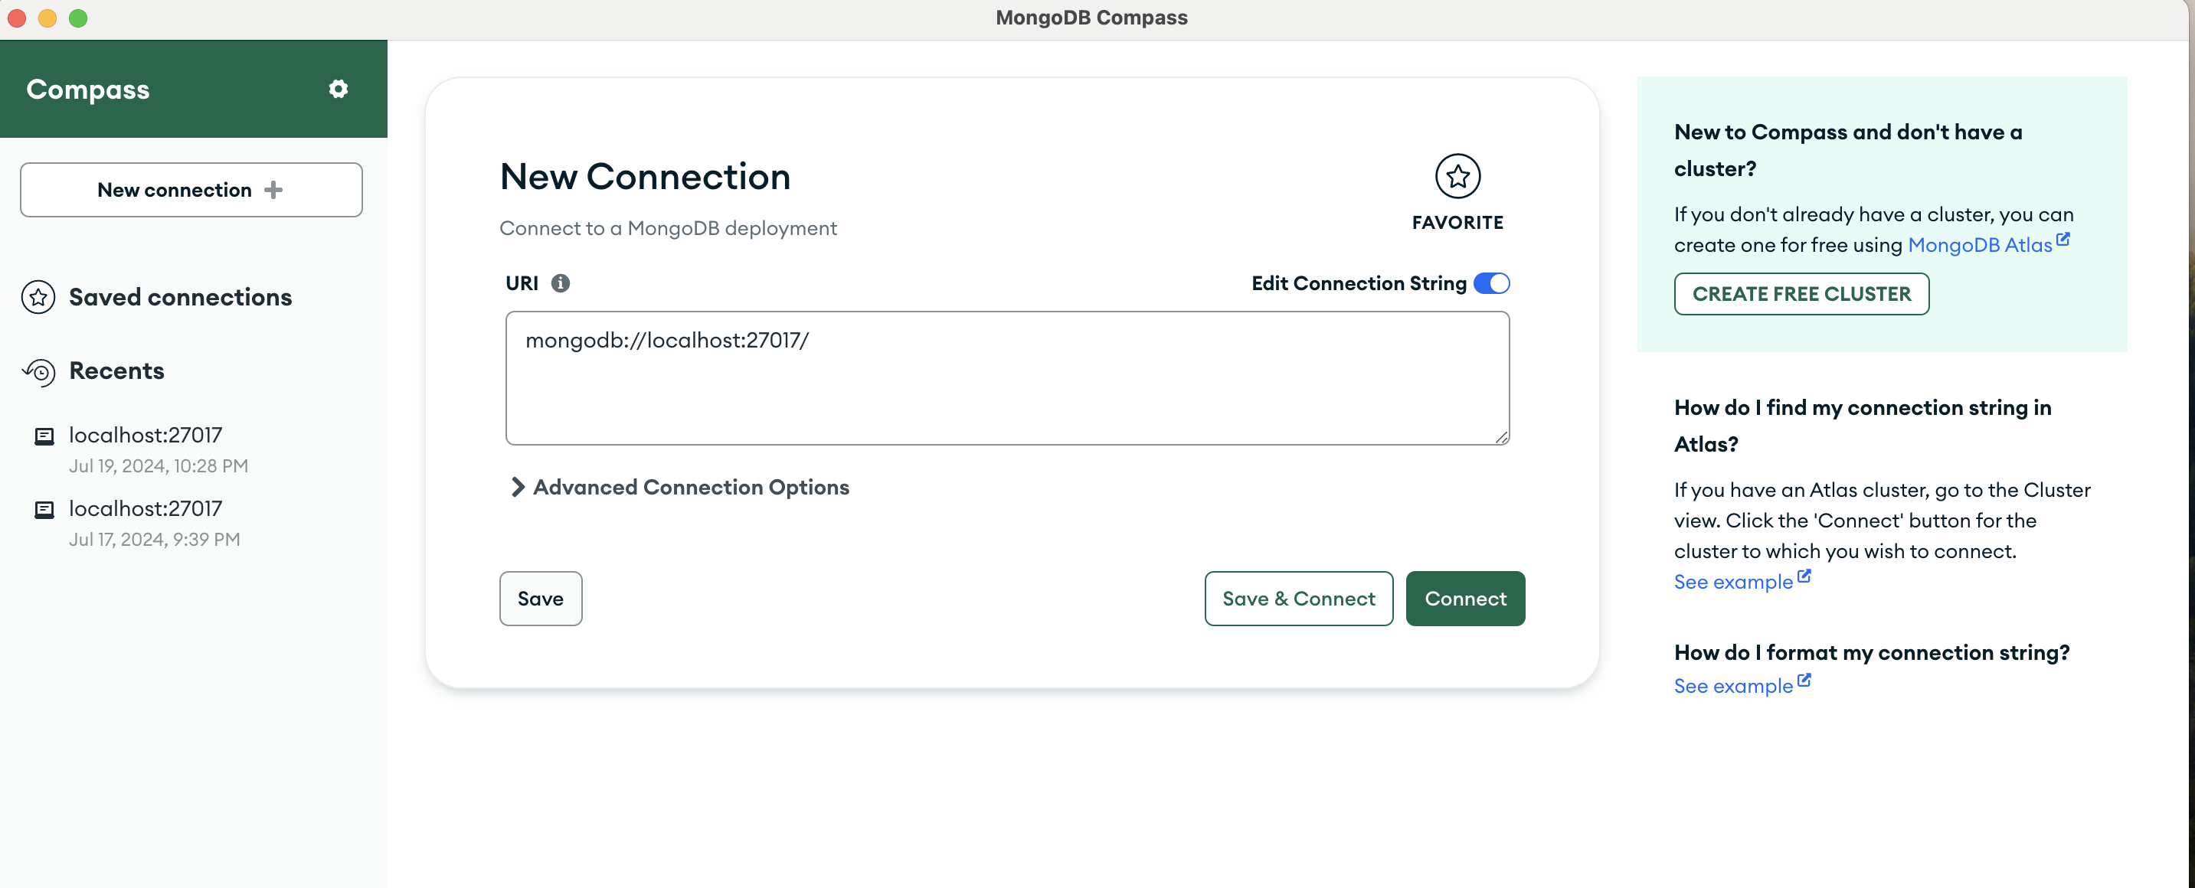

# **DATA MODEL CREATION**

To create the MongoDB data model, we need to translate these tables into collections and documents. MongoDB collections will correspond to tables, and documents within these collections will represent rows. Migrating a MySQL schema to MongoDB involves several key considerations, including data type mapping, schema design, validation, and performance optimization.

1. Data types in MySQL and MongoDB differ significantly. Here’s a mapping of common data types from MySQL to MongoDB:

| **MySQL Data Type** | **MongoDB Data Type** | **Description** |
| --- | --- | --- |
| INT | Number (int) | Integer values. |
| VARCHAR | String | Variable-length string. |
| TEXT | String | Large text data. |
| DECIMAL | Number (double) | Fixed-point decimal values. |
| DATETIME | Date | Date and time values. |
| BOOLEAN | Boolean | True/False values. |
| BLOB | BinData | Binary data. |
| JSON | Document (Embedded object) | JSON objects are represented as embedded documents. |

1. Unlike MySQL, MongoDB is schema-less, meaning it doesn’t enforce a schema at the database level. However, for consistency and validation, it’s often beneficial to design a schema. Here’s how you can translate a relational schema into a document-based schema:

|  |  |
| --- | --- |
| **SQL - Products Table:** | **NO SQL - Products Collection:** |
| CREATE TABLE Products (  product_id INT PRIMARY KEY,  seller_id INT,  category_id INT,  name VARCHAR(100),  description TEXT,  price DECIMAL(10, 2),  quantity INT,  product_image VARCHAR(255),  product_rating DECIMAL(2,1)  ); | {  "product_id": 1,  "seller_id": 1,  "category_id": 10,  "name": "Laptop XYZ",  "description": "High-performance laptop with 16GB RAM and 512GB SSD",  "price": 1200.00,  "quantity": 50,  "product_image": "laptop_xyz.png",  "product_rating": 4.5  } |

MongoDB provides schema validation using JSON Schema. This can help ensure data integrity similar to relational database constraints.

**Products Collection Validation:**

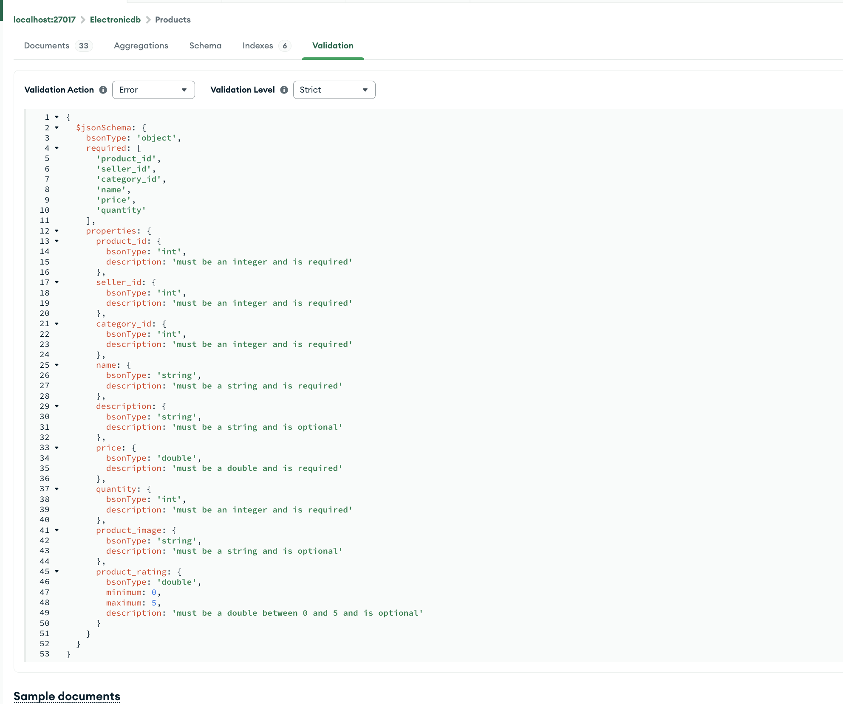

# **DATA STRUCTURE**

When migrating from a SQL database to MongoDB, the data structure and schema design undergo significant changes. MongoDB is a NoSQL database that uses a flexible, document-based model, which is quite different from the rigid, table-based structure of SQL databases[6]. Here we discuss about the data structure for a table in our SQL schema and how it translates into MongoDB collections and documents.

**Data Structure for Each Table**

**1. Addresses**

In SQL, addresses are stored in a separate table and referenced by other tables using foreign keys. In MongoDB, addresses can be embedded within documents that reference them (e.g., Users, Sellers).

|  |  |
| --- | --- |
| **SQL - Addresses Table:** | **NO SQL - Addresses Collection:** |
| CREATE TABLE Addresses (  address_id INT PRIMARY KEY,  address_line1 VARCHAR(255),  address_line2 VARCHAR(255),  city VARCHAR(100),  state VARCHAR(100),  zip_code VARCHAR(20),  country VARCHAR(100)  ); | {  "address_id": 1,  "address_line1": "123 Main St",  "address_line2": "Apt 4B",  "city": "Metropolis",  "state": "NY",  "zip_code": "12345",  "country": "USA"  } |

**2. Users**

In MongoDB, user documents can include embedded address documents rather than using foreign keys.

|  |  |
| --- | --- |
| **SQL - Users Table:** | **NO SQL - Users Collection:** |
| CREATE TABLE Users (  user_id INT PRIMARY KEY,  username VARCHAR(100) UNIQUE,  password_hash VARBINARY(255),  email VARCHAR(100) UNIQUE,  contact_details VARCHAR(255),  user_image VARCHAR(255),  address_id INT,  payment_info TEXT,  FOREIGN KEY (address_id) REFERENCES Addresses(address_id) ON DELETE SET NULL  ); | {  "user_id": 1,  "username": "john_doe",  "password_hash": "hashed_password",  "email": "john@example.com",  "contact_details": "123-456-7890",  "user_image": "john_doe.png",  "address": {  "address_id": 1,  "address_line1": "123 Main St",  "address_line2": "Apt 4B",  "city": "Metropolis",  "state": "NY",  "zip_code": "12345",  "country": "USA"  },  "payment_info": "Visa ending in 1234"  } |

**Key Differences**

|  |  |  |
| --- | --- | --- |
|  | SQL | NO SQL |
| **Normalization vs. Denormalization**: | Often uses normalized data to minimize redundancy. Foreign keys are used to establish relationships. | Encourages embedding (denormalization) for related data to optimize read operations. |
| **Schema Flexibility**: | Strict schema. Each table must follow a predefined schema. | Schema-less. Each document in a collection can have a different structure. |
| Performance | Uses JOIN operations to combine data from different tables | Embeds related data within a single document to avoid JOINs, improving performance. |

# **DATA MODELING**

Here are the data model that are in out part 2 of our project.

## **User Authentication and Registration:**

**These** are the critical components of the **GadgetGalaxy** application, ensuring secure access and personalized experiences for users. These features are designed to safeguard user information while providing a seamless onboarding process for new users and a straightforward login mechanism for returning users.

### USER INTERFACE DESIGN

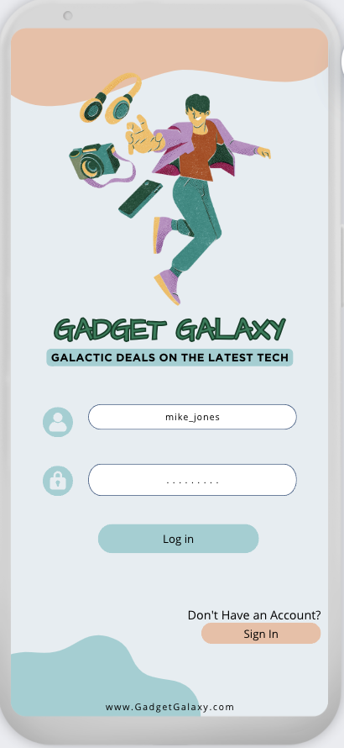 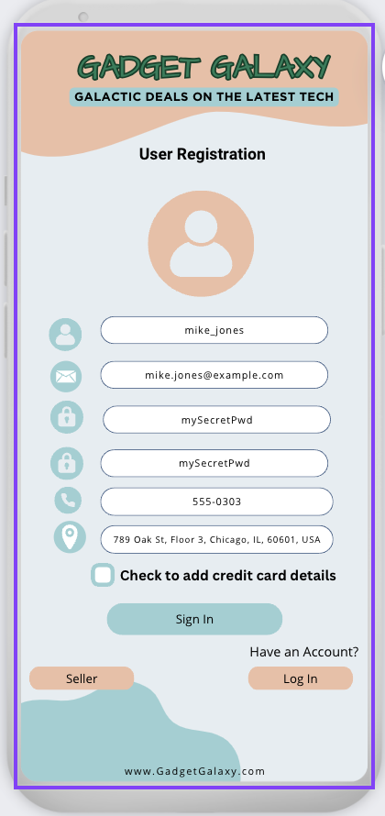 

### User Registration and Authentication

Login User – screen 1

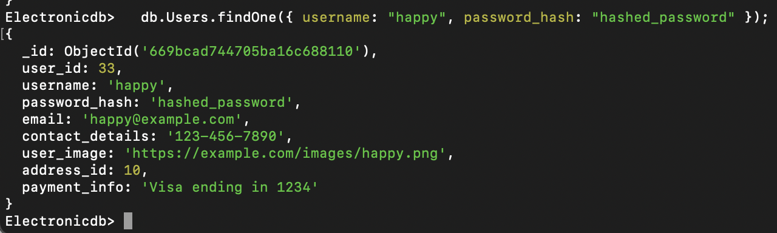

In the backend, we verify with a hashed password and move to the home page.

Create user – Screen 2

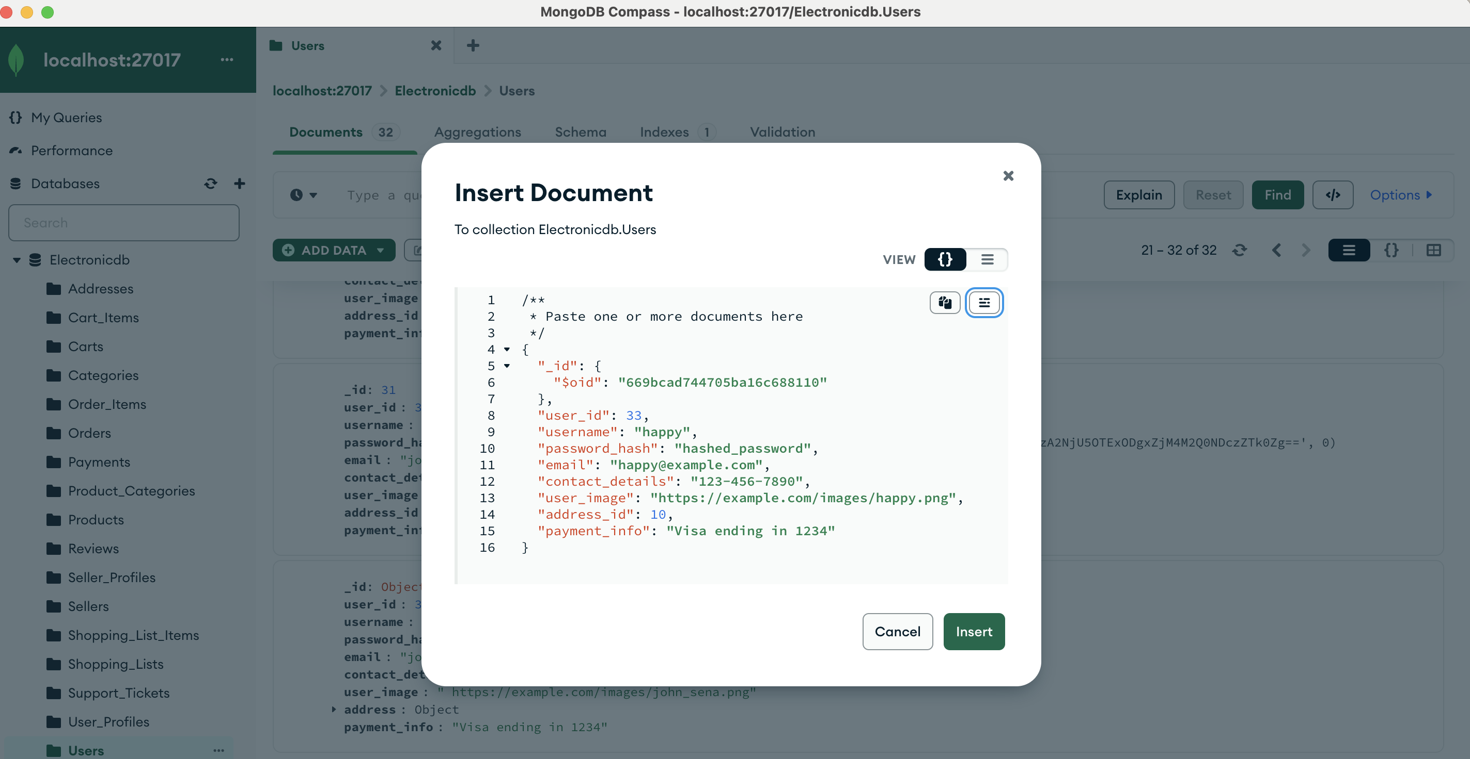

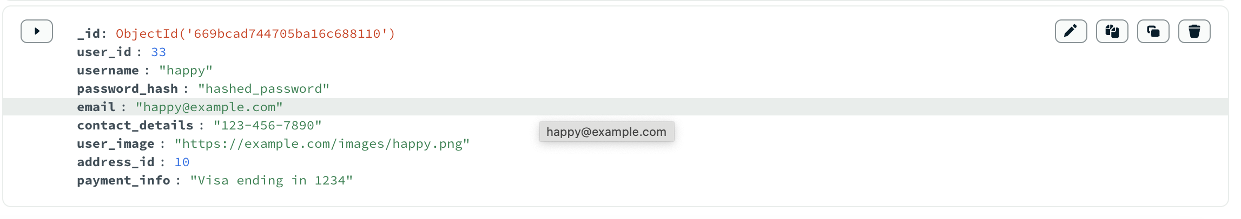

Verify User- Screen 3

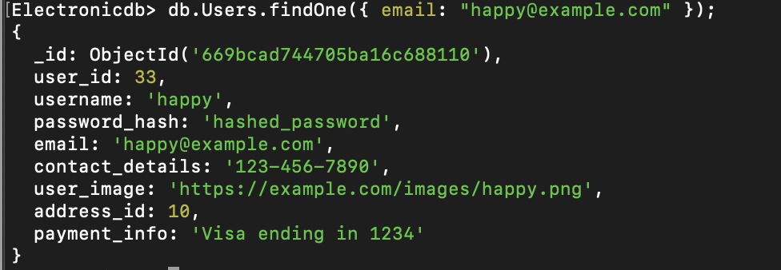

## PRODUCT MANAGEMENT

**Product Management** is a core functionality of the **GadgetGalaxy** platform, enabling sellers to effectively manage their inventory and ensuring an all-in-one shopping experience for users. Sellers register or log in and have the ability to view add, edit, and delete product listings directly from their dedicated seller page. For this, we have created Sellers, Products, and Categories tables.

### USER INTERFACE DESIGN

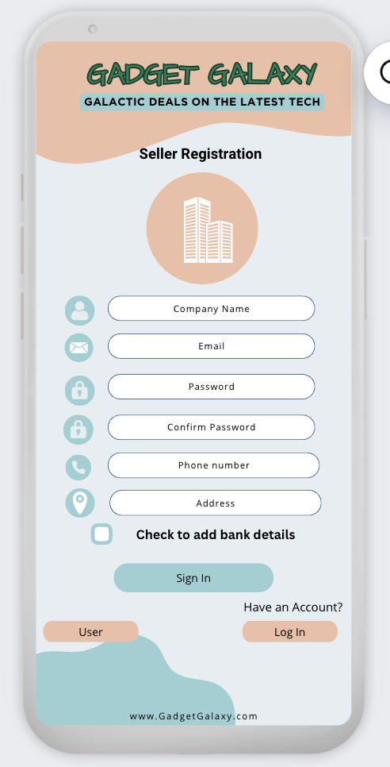 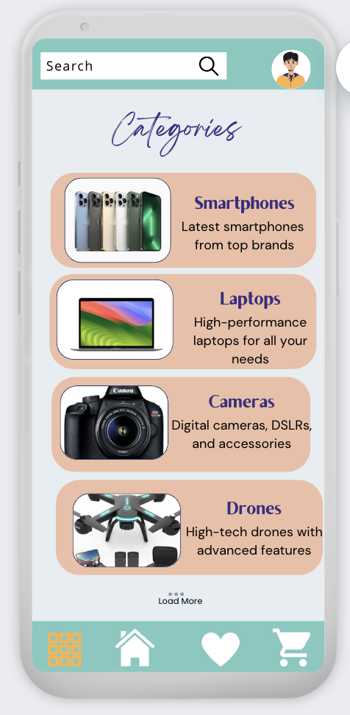 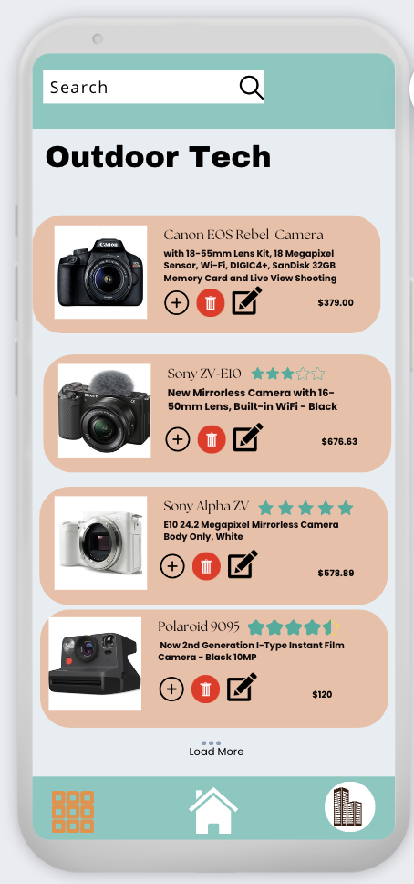

### Seller Registration

**Seller Registration** allows third-party companies to join the **GadgetGalaxy** platform and list their products. The process is designed to be straightforward and secure, ensuring that sellers can quickly start managing their product listings. Sellers provide necessary information such as company name, contact details, password, and business logo. The password is hashed using a secure hashing algorithm before being stored in the database. Seller information, including the hashed password, is securely stored in the Sellers table in the MongoDB database. Optionally, sellers may need to verify their email addresses or provide additional documentation for verification.

Seller Registration -screen1

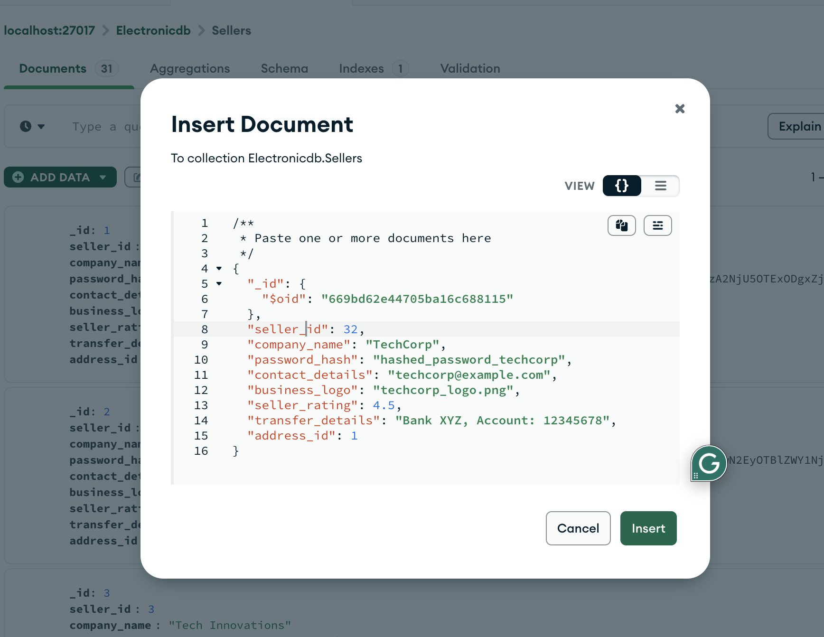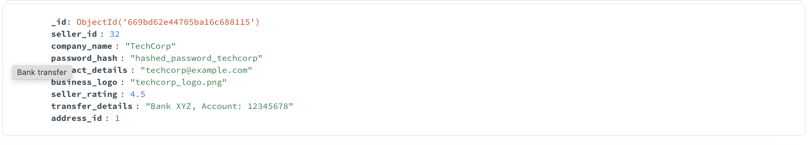

### Categories Display on Category Page

The **Category Page** displays all available product categories, allowing users to browse products within a specific category. Each category has a name and description, providing users with a clear understanding of the product types available.

Categories Display -Screen 2

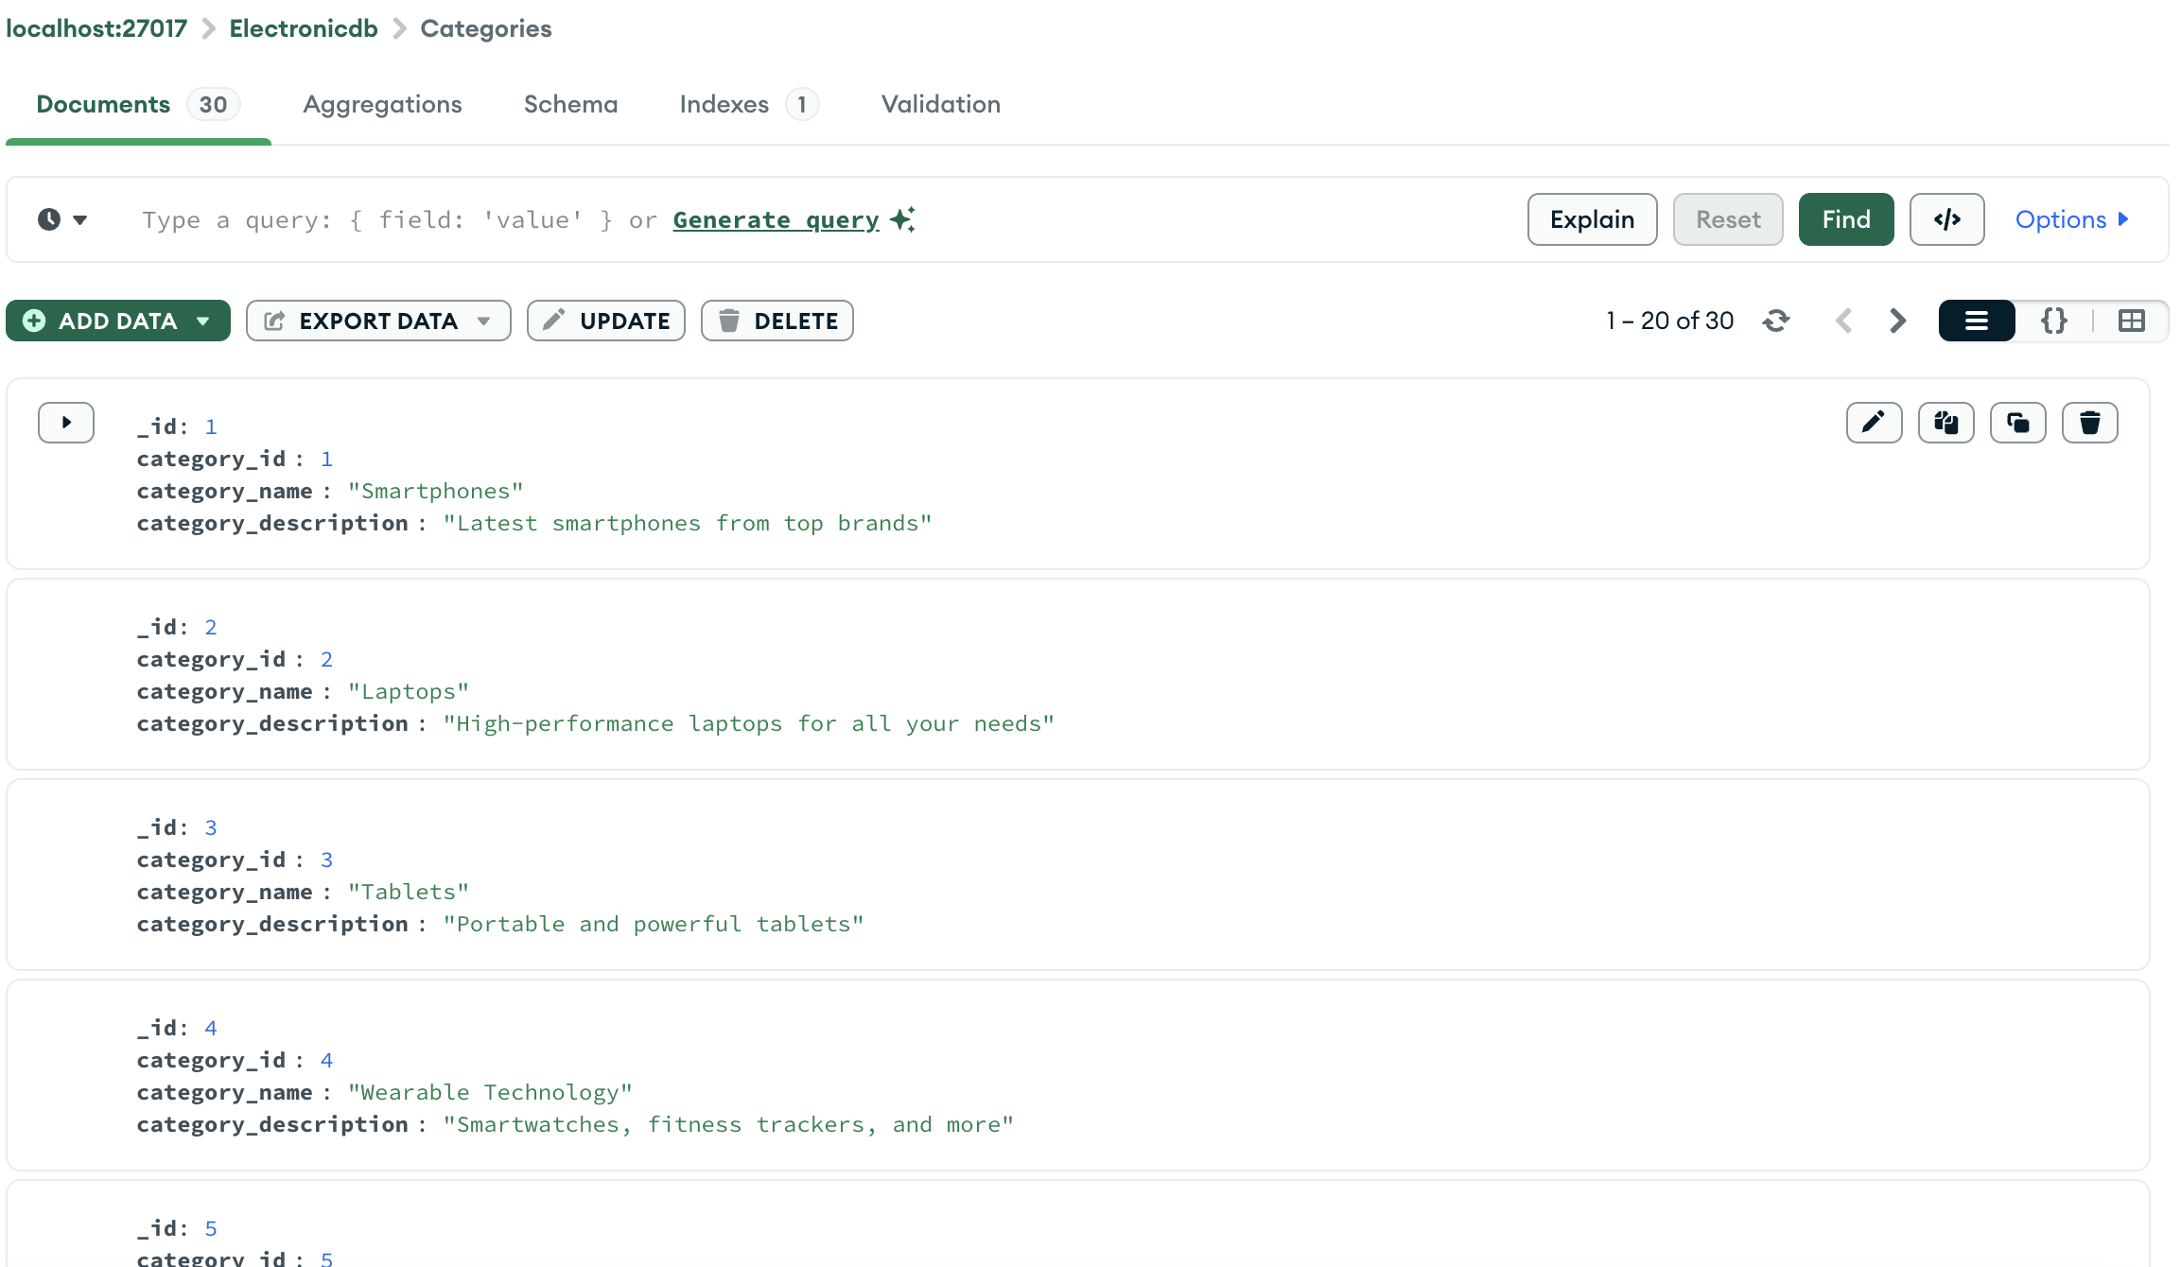

### Product Management on Seller Page

Sellers can manage their products directly from their dedicated **Seller Page**. This includes adding new products, editing existing products, and deleting products that are no longer available.

Seller – Product Management Screen 3

Adding Products: Sellers can add new products by providing details such as name, description, price, quantity, category, and product image.

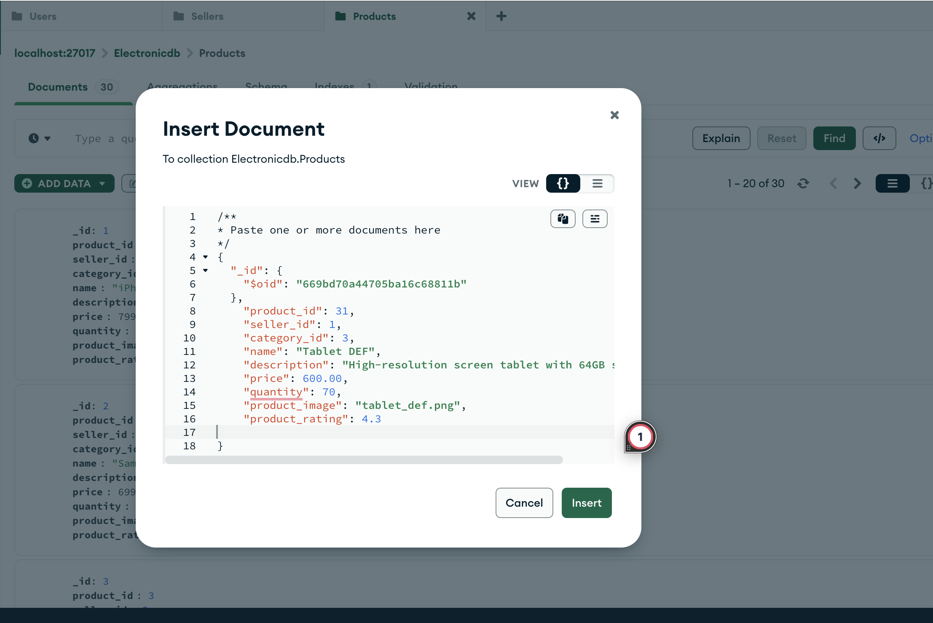

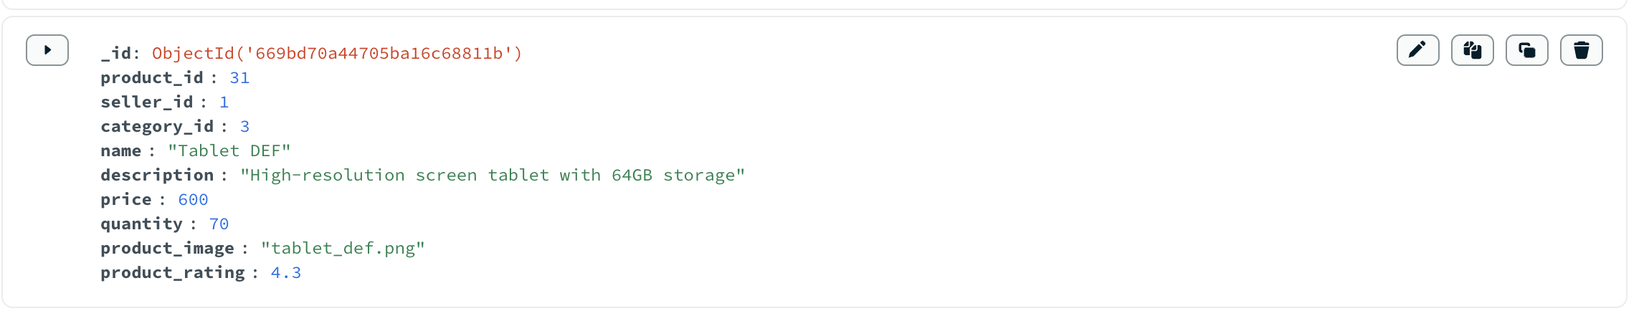

Editing Products: Sellers can update the details of existing products. This includes changing the name, description, price, quantity, category, and product image.

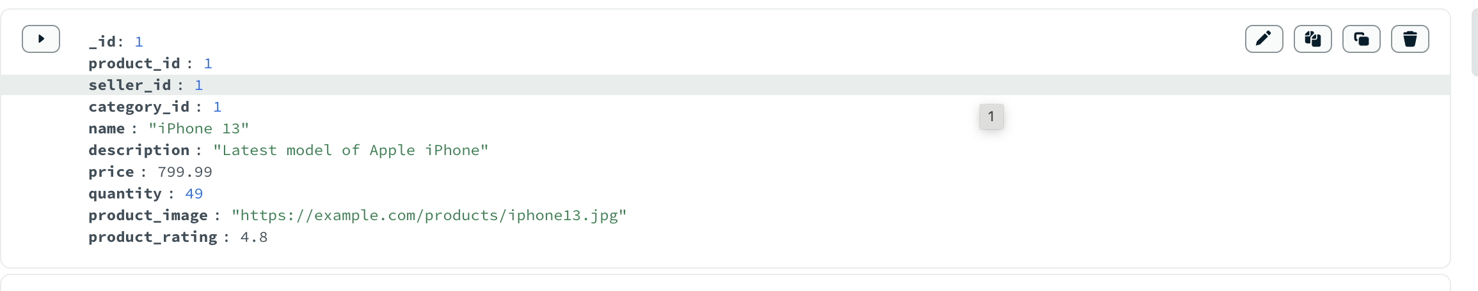

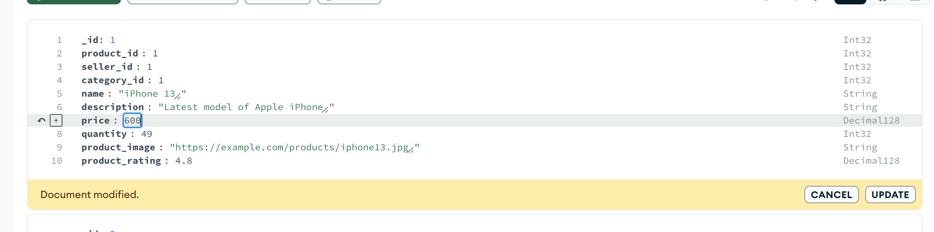

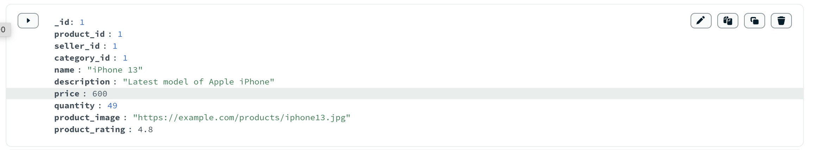

Deleting Products: Sellers can remove products from their listings if they are no longer available for sale.



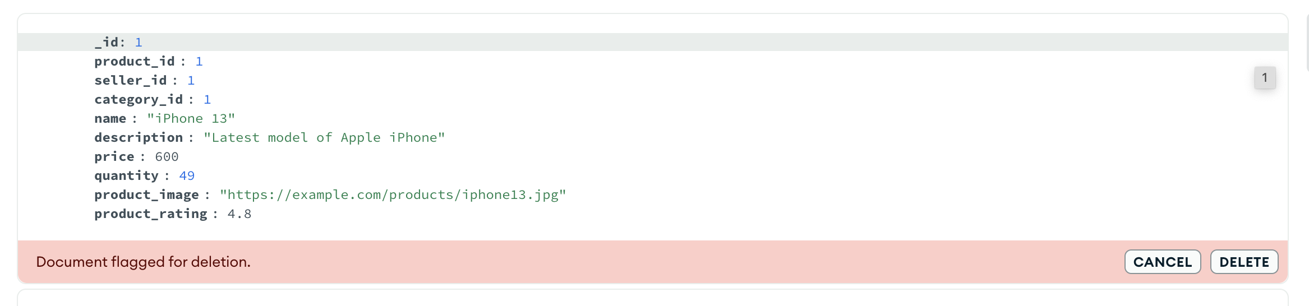

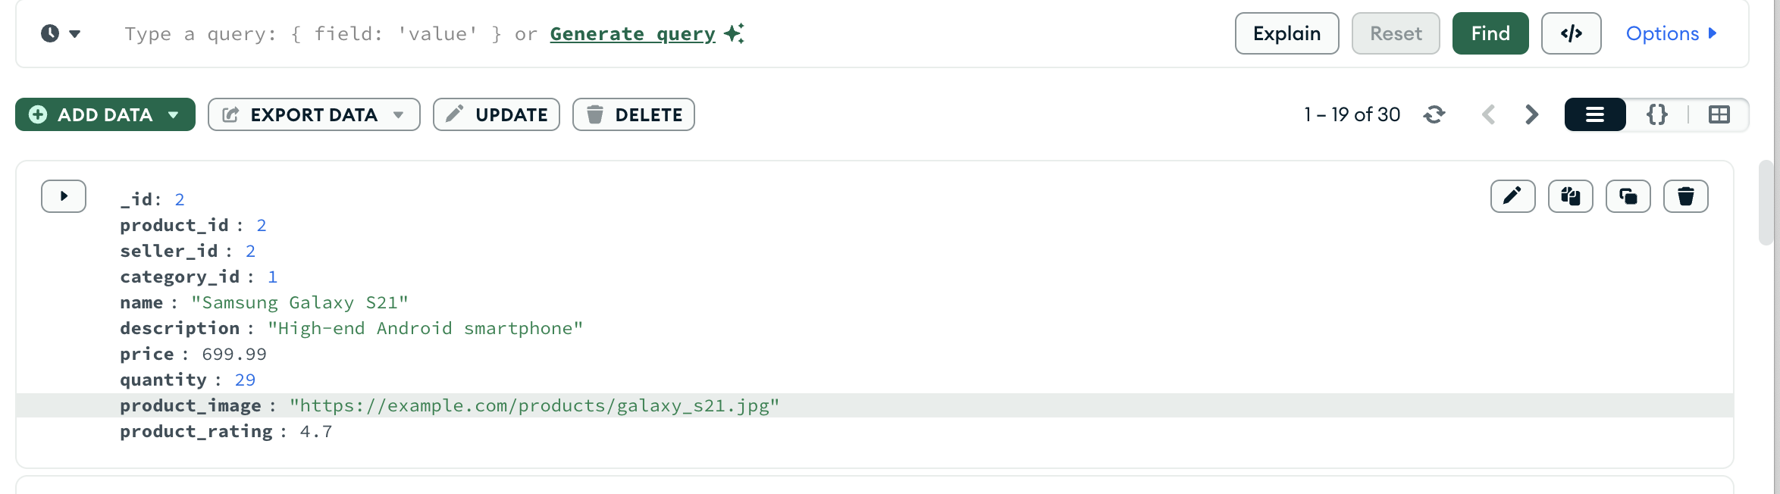

## PRODUCT LISTINGS

**In Product Listing** the products are displayed on the home page and platform’s category pages, allowing users to browse and search for items based on various filters and keywords. They can search for an item, add to card or shopping list.They can we the rating, price etc.

### USER INTERFACE DESIGN

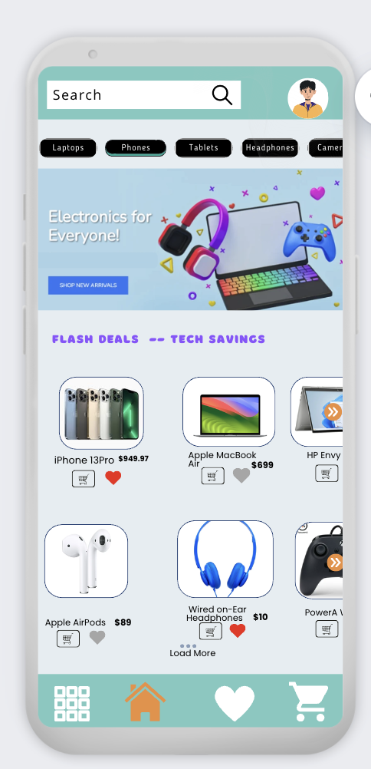 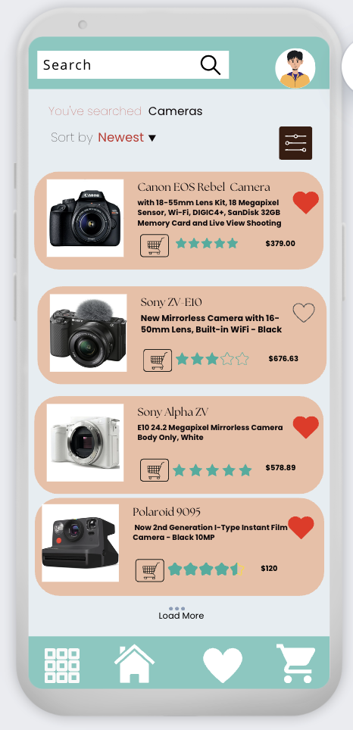

Home Page – screen1

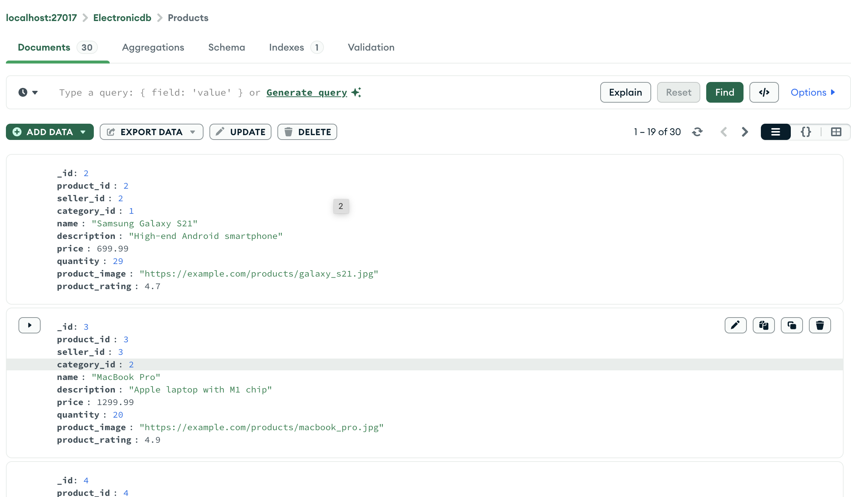

Filter Page – Screen 2

To filter products based on recently added items and include only those name related to “Apple” and description related to “Apple”

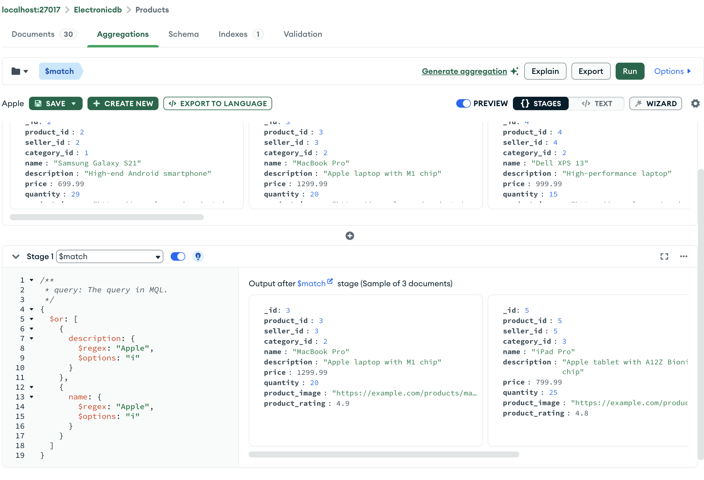

## SHOPPING CART AND ORDER MANAGEMENT

The **Shopping Cart** feature in **GadgetGalaxy** allows users to conveniently add products they wish to purchase and manage them before proceeding to checkout. This feature provides a user-friendly interface where customers can review the items they have selected, modify quantities, and remove products if necessary. The users can add products to their shopping cart directly from the product listing or detail pages. Users can view their shopping cart, which displays all selected items along with their quantities, prices, and total cost, and can update the quantity of each item in their cart or remove items they no longer wish to purchase.

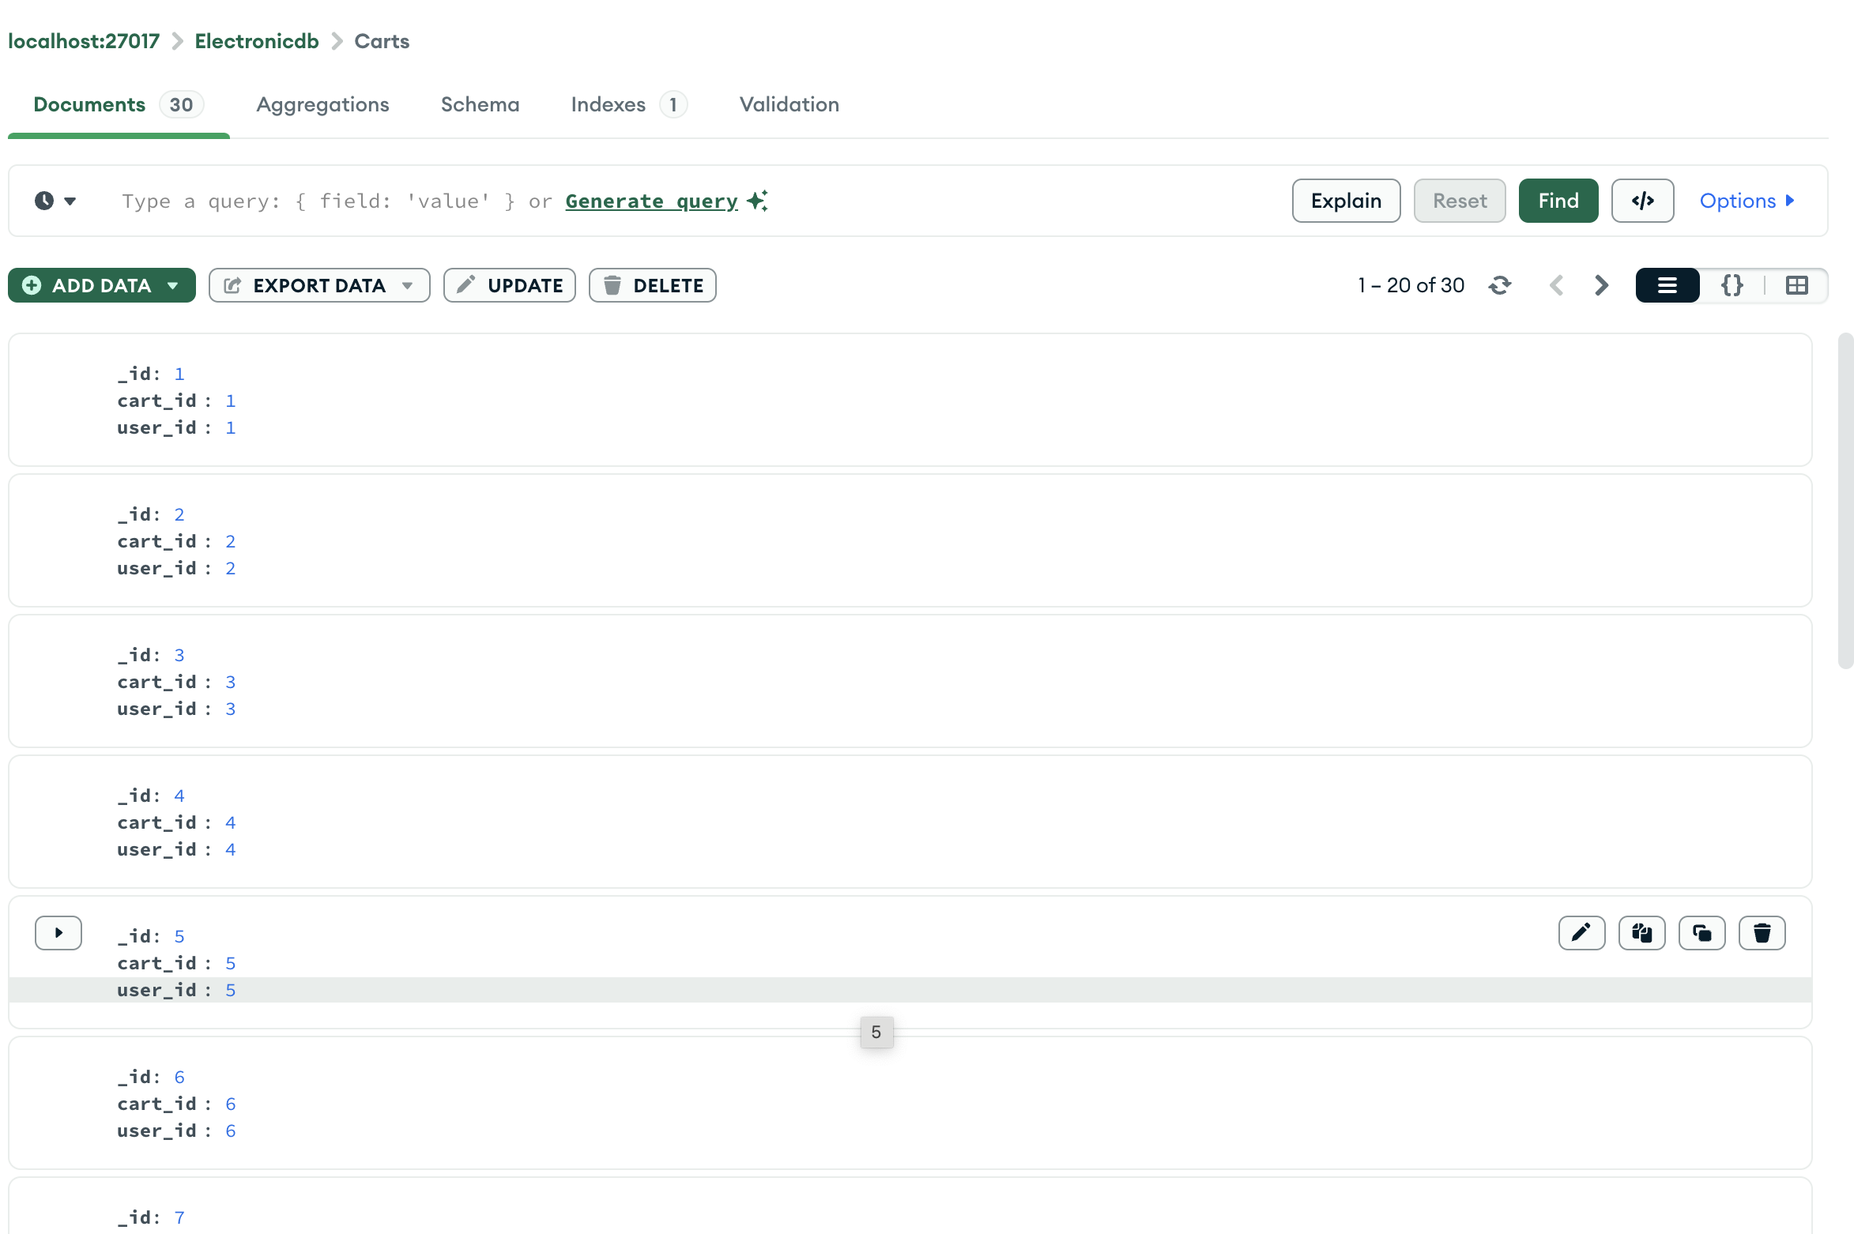

The order management process in GadgetGalaxy is designed to be secure, efficient, and straightforward, guiding users through the steps necessary to complete their purchase. This process includes confirming the items in the cart, providing shipping details, selecting a payment method, and placing the order. Before finalizing the purchase, users are presented with an order summary that includes the list of items, their quantities, individual prices, and the total cost. Once the payment is processed, users receive an order confirmation with details about their purchase and estimated delivery times.

### USER INTERFACE DESIGN

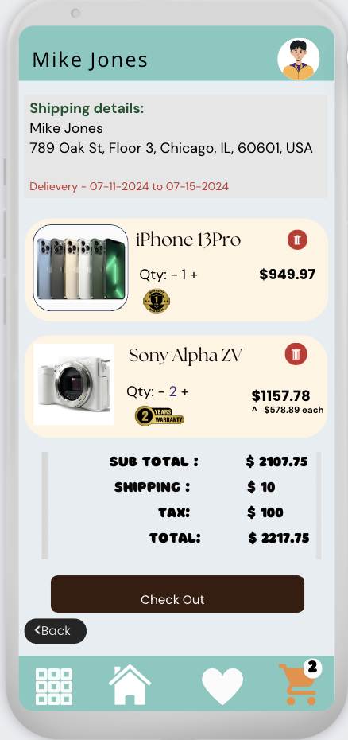 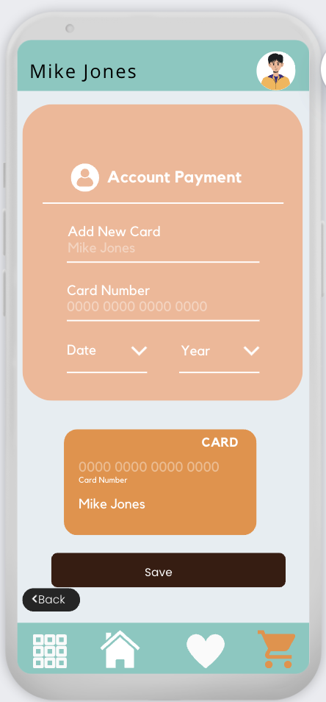 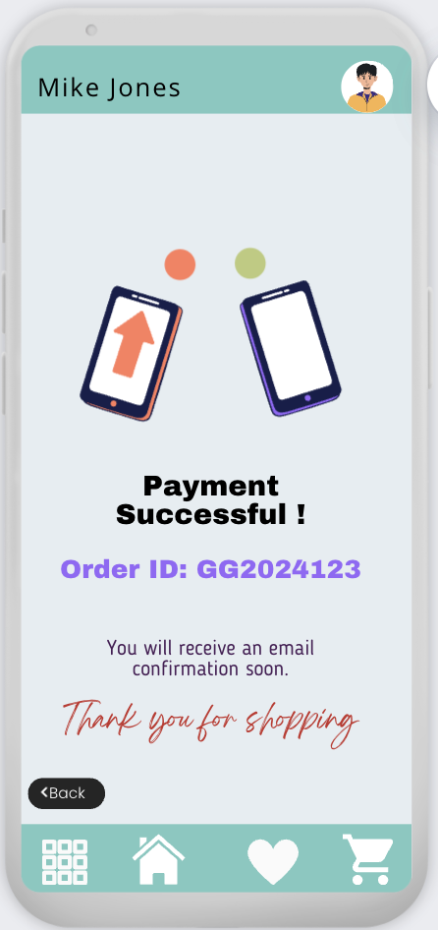

Cart page – Screen1

**Delete cart item:**

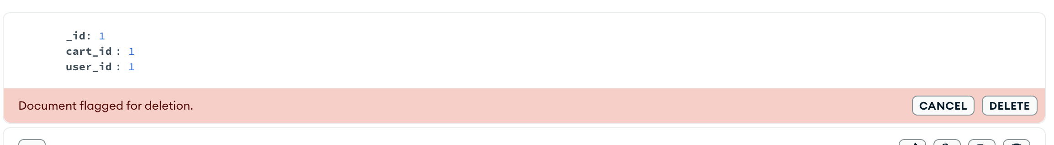

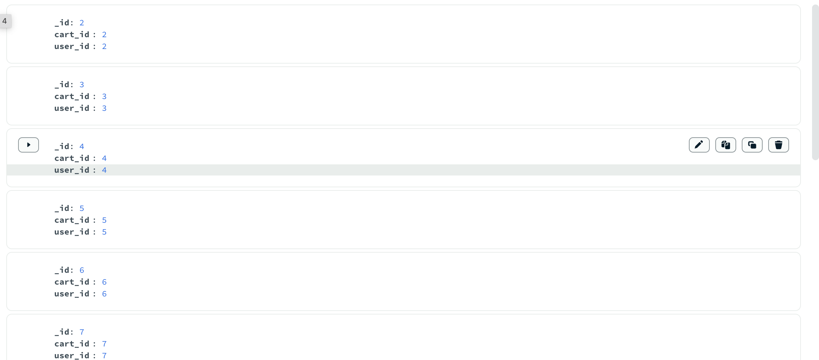

To show the total or subtotal for all items in a specific cart, we can use an SQL query that calculates the sum of the total price for each item in the cart.

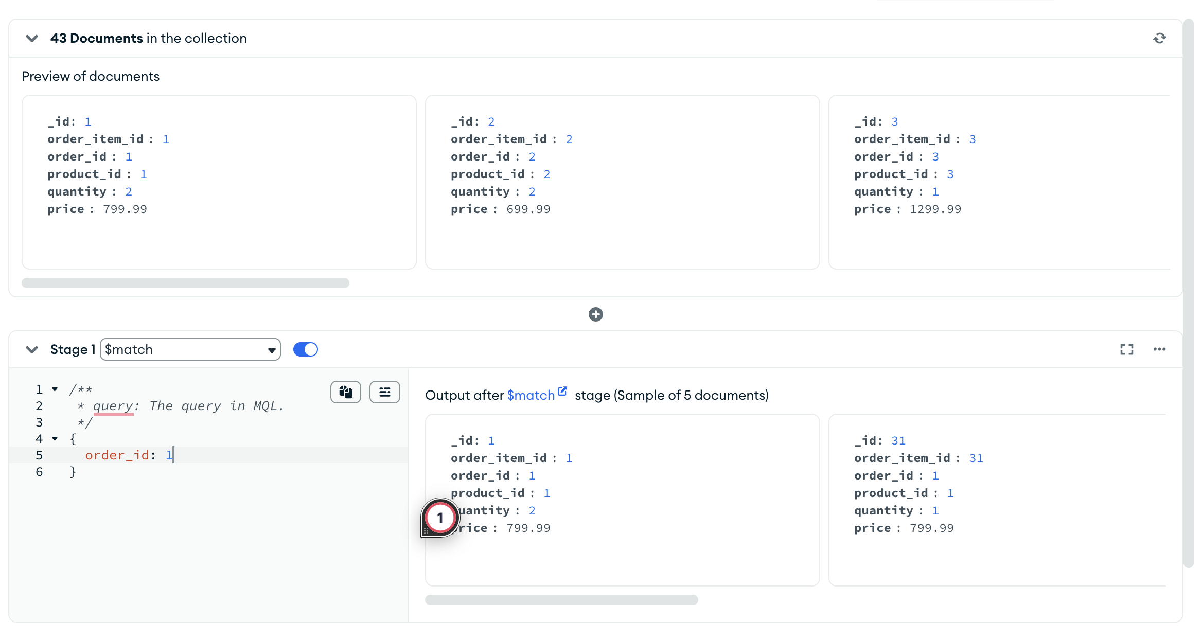

Total order amount calculation

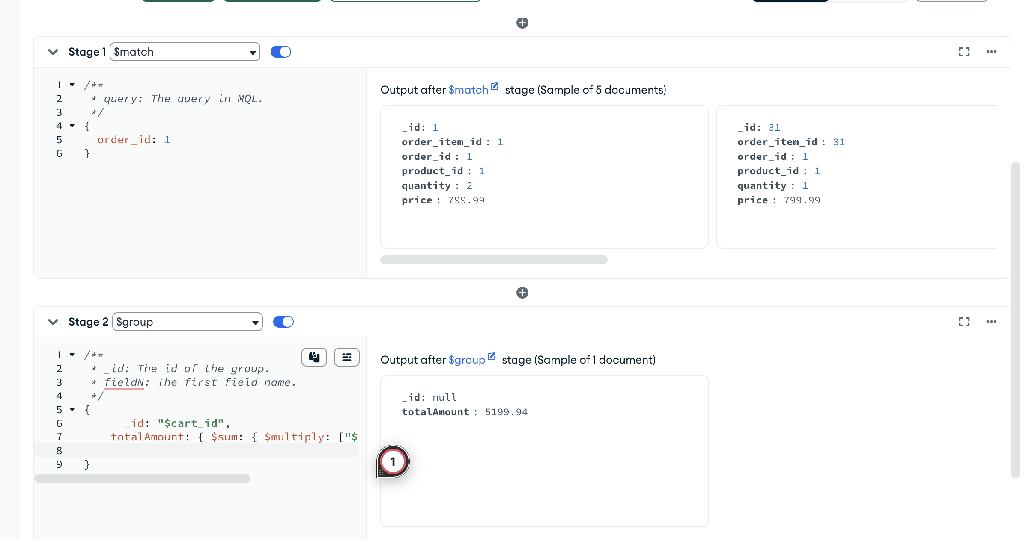

## USER AND SELLER PROFILES

User Profiles in GadgetGalaxy serve as personalized spaces where users can manage their account information, view their order history, and update their contact details. The user profile enhances the shopping experience by allowing users to easily access and modify their personal information and keep track of their purchases.

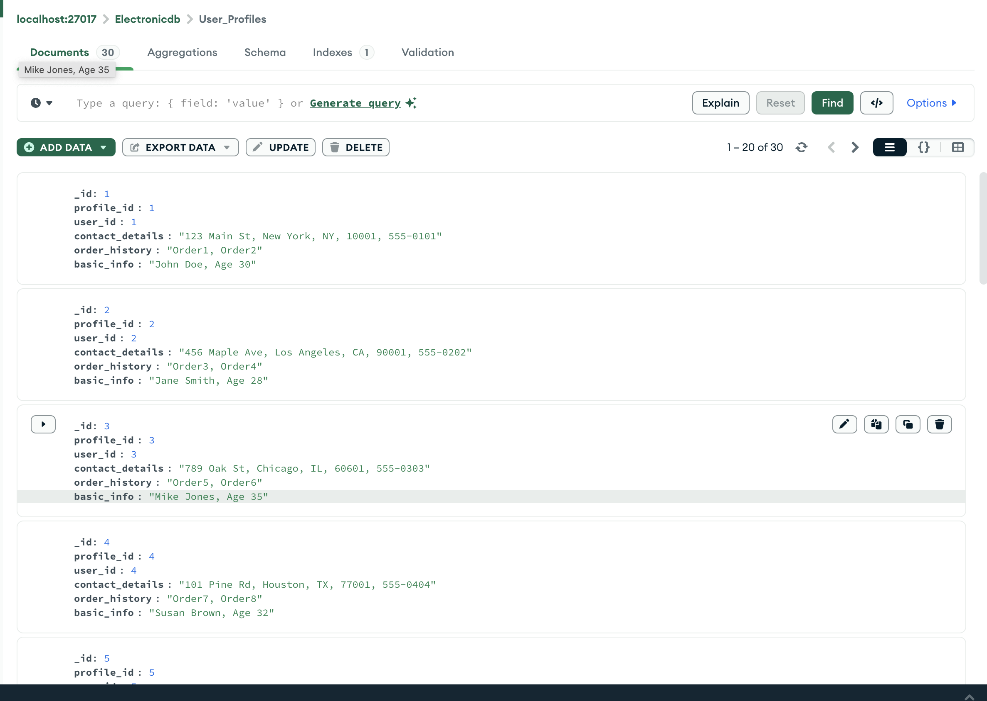

Seller Profiles in GadgetGalaxy provide sellers with a comprehensive interface to manage their products, view sales data, and update their business information. This feature ensures that sellers can efficiently handle their operations and offer the best service to customers. Sellers can update their company name, contact details, business logo, and other relevant information

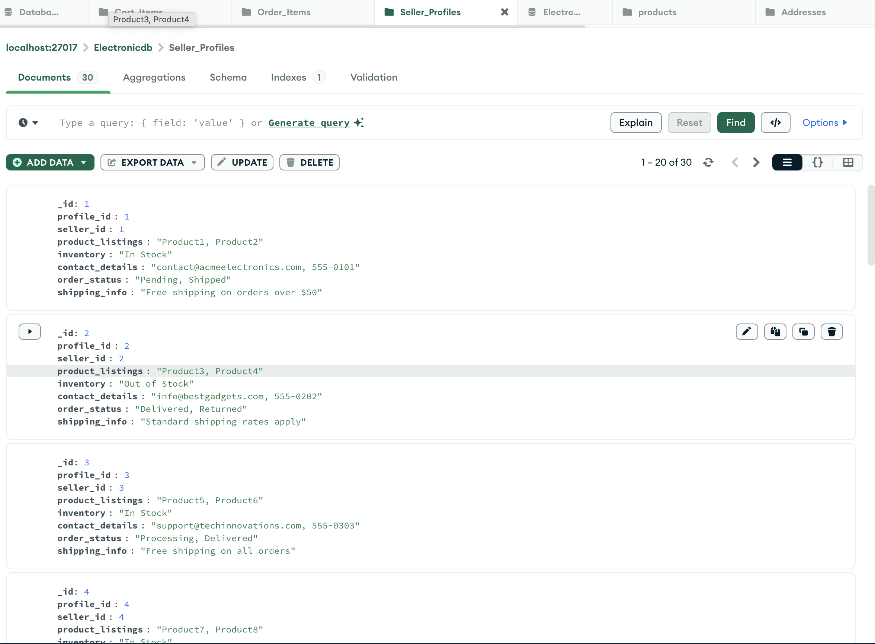

Reviews data:

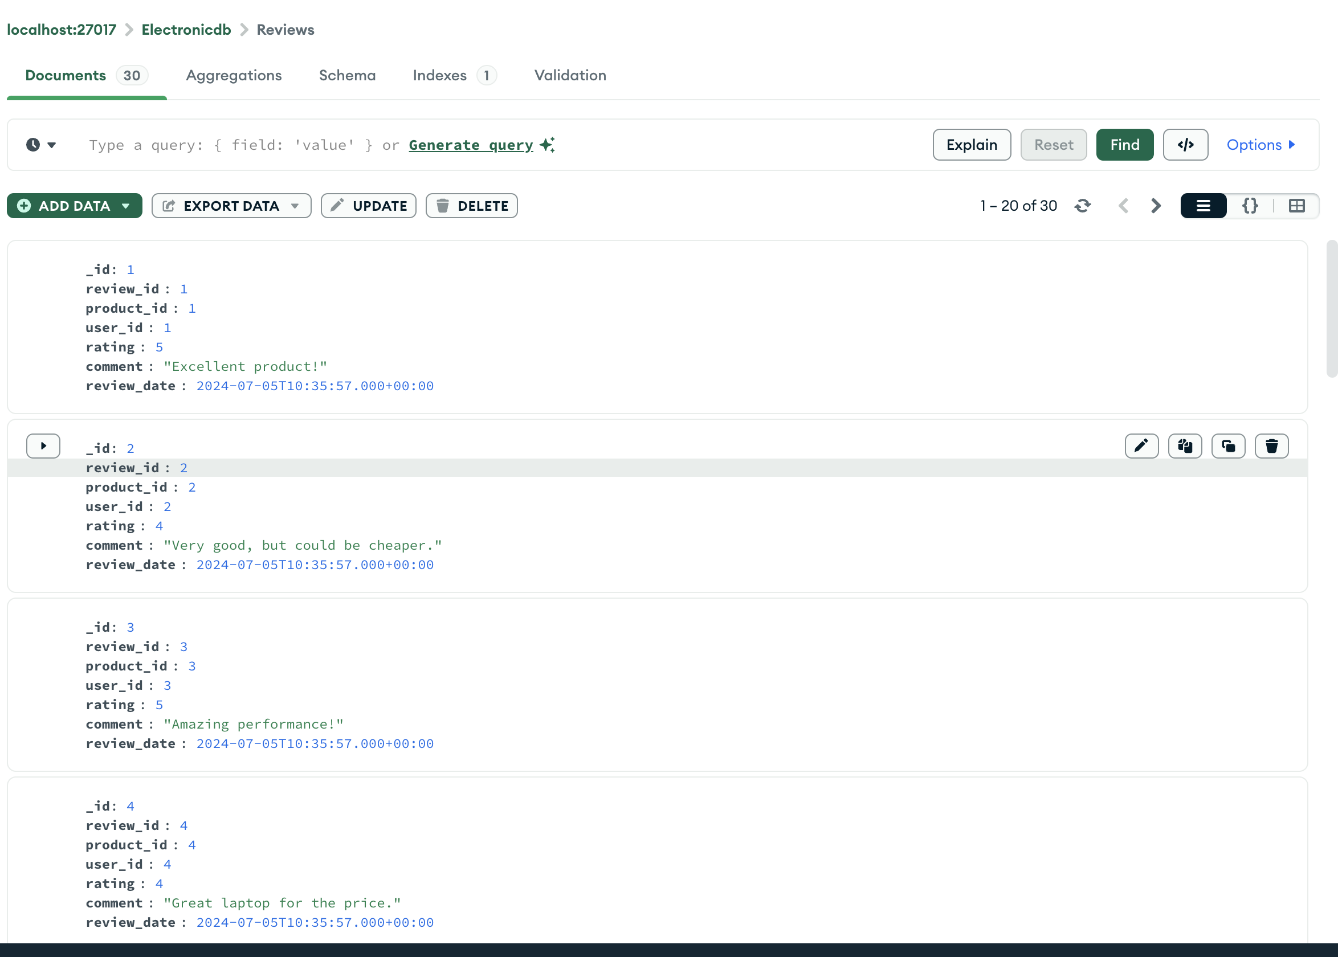

### USER INTERFACE DESIGN

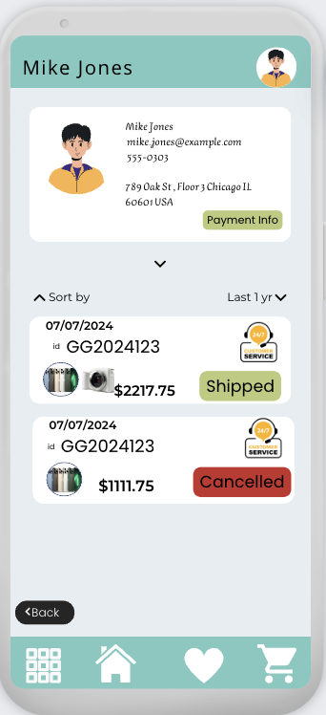 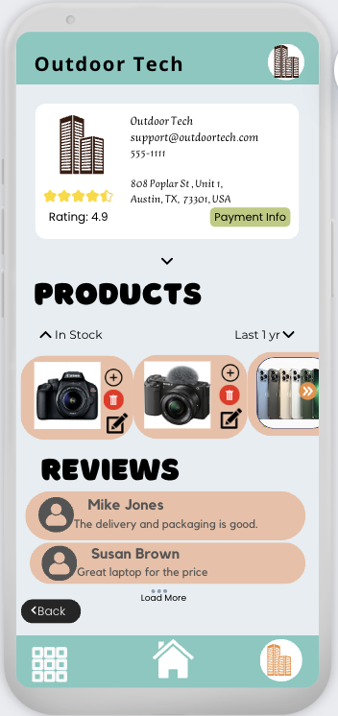

User Profile Screen 1

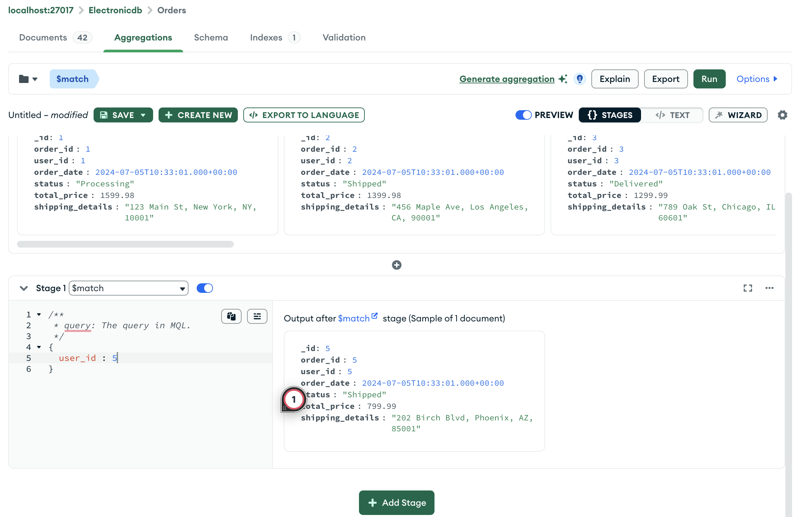

## RELATED TABLES

In addition to the core tables for users, sellers, products, orders, and reviews, GadgetGalaxy incorporates several auxiliary tables to enhance the user experience and provide comprehensive support features. These additional tables include Shopping Lists and their Items, Warranties, and Support Tickets

1. The Support_Tickets table enables users to raise issues or queries related to their purchases. Each support ticket includes the user ID, product ID, issue description, status, and timestamps for creation and updates. This structured approach to handling support requests helps GadgetGalaxy provide timely and efficient customer service, ensuring that user concerns are addressed promptly and effectively.

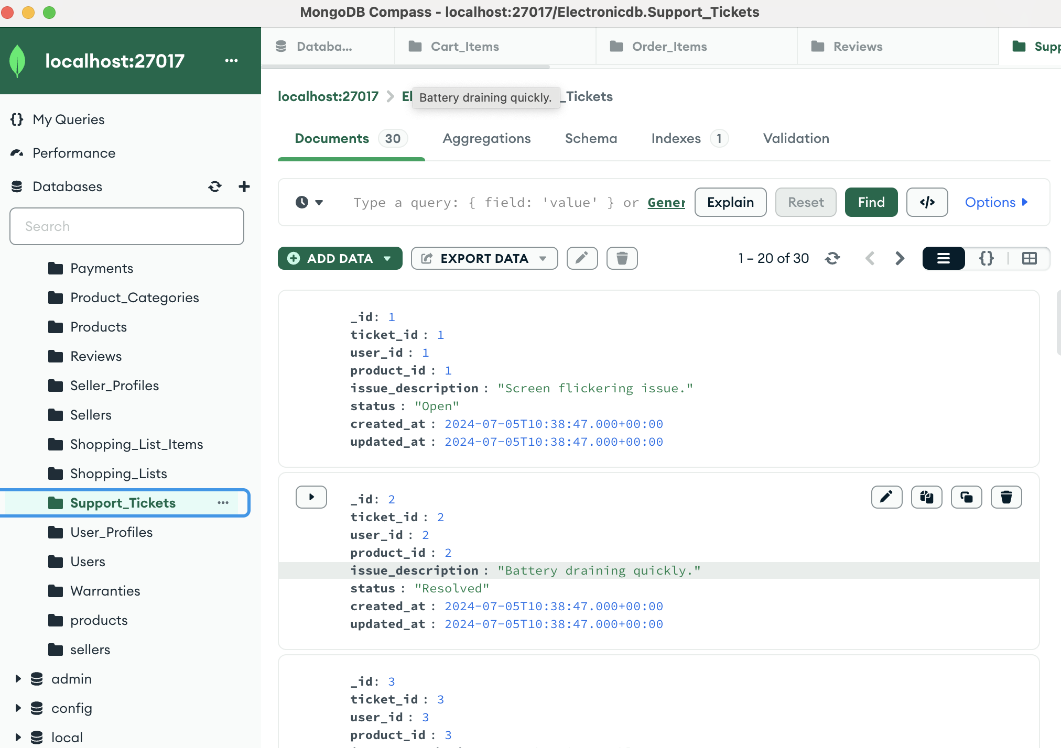

1. The **Warranties** table stores warranty information for products purchased by users. This table includes details such as the warranty period, start and end dates, and associated order and product IDs. By maintaining detailed warranty records, **GadgetGalaxy** ensures users can easily access and verify their warranty information, facilitating smoother post-purchase support and claims.

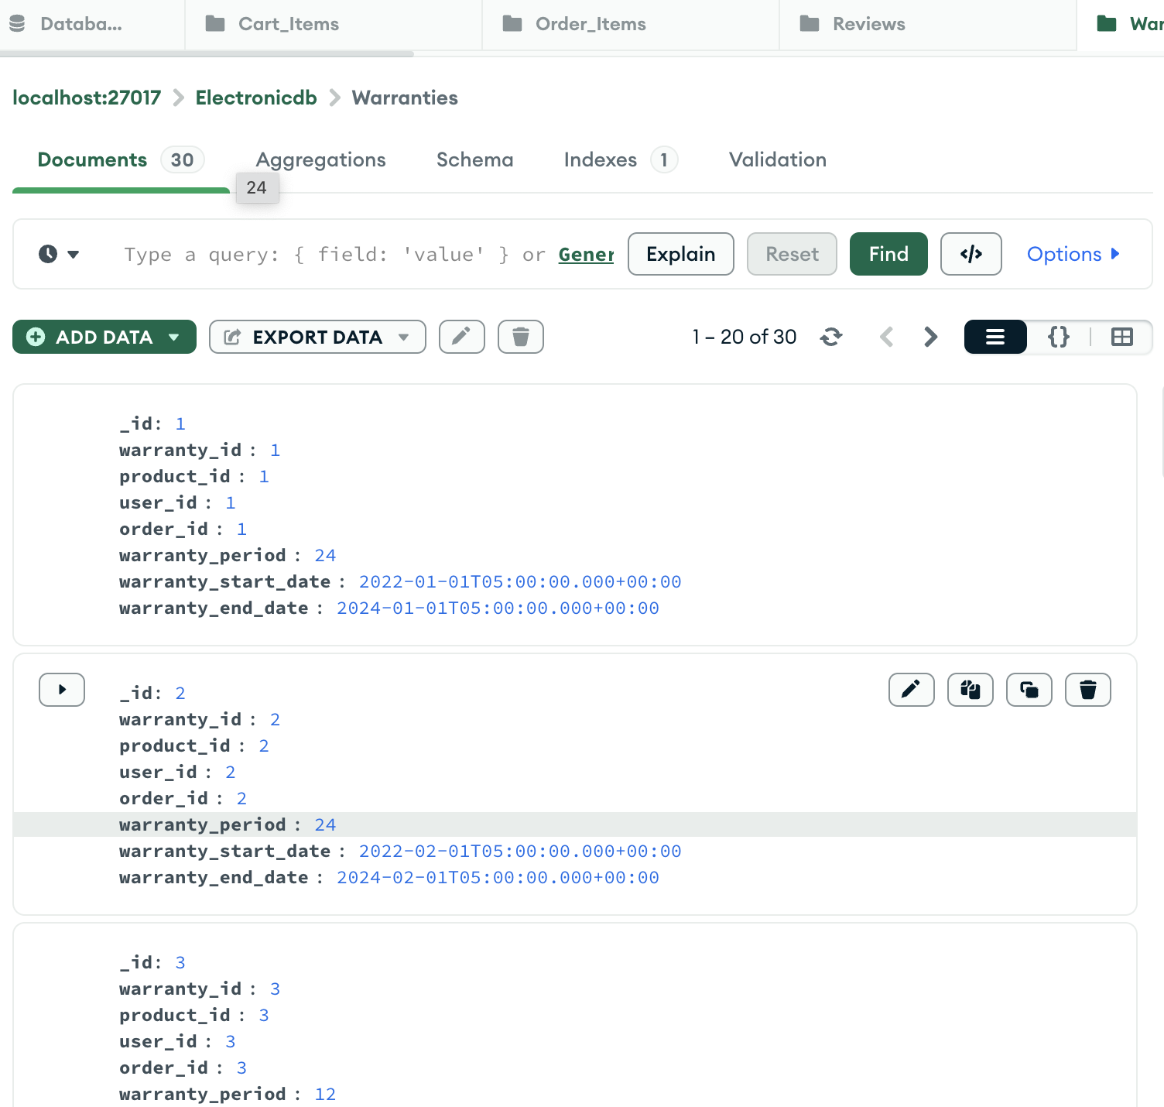

1. The Shopping_List and Shopping_List_Items tables allow users to create personalized lists of products they are interested in but not ready to purchase immediately. This feature enables users to save and organize products for future reference. Each shopping list can contain multiple items, with each item linked to a specific product.

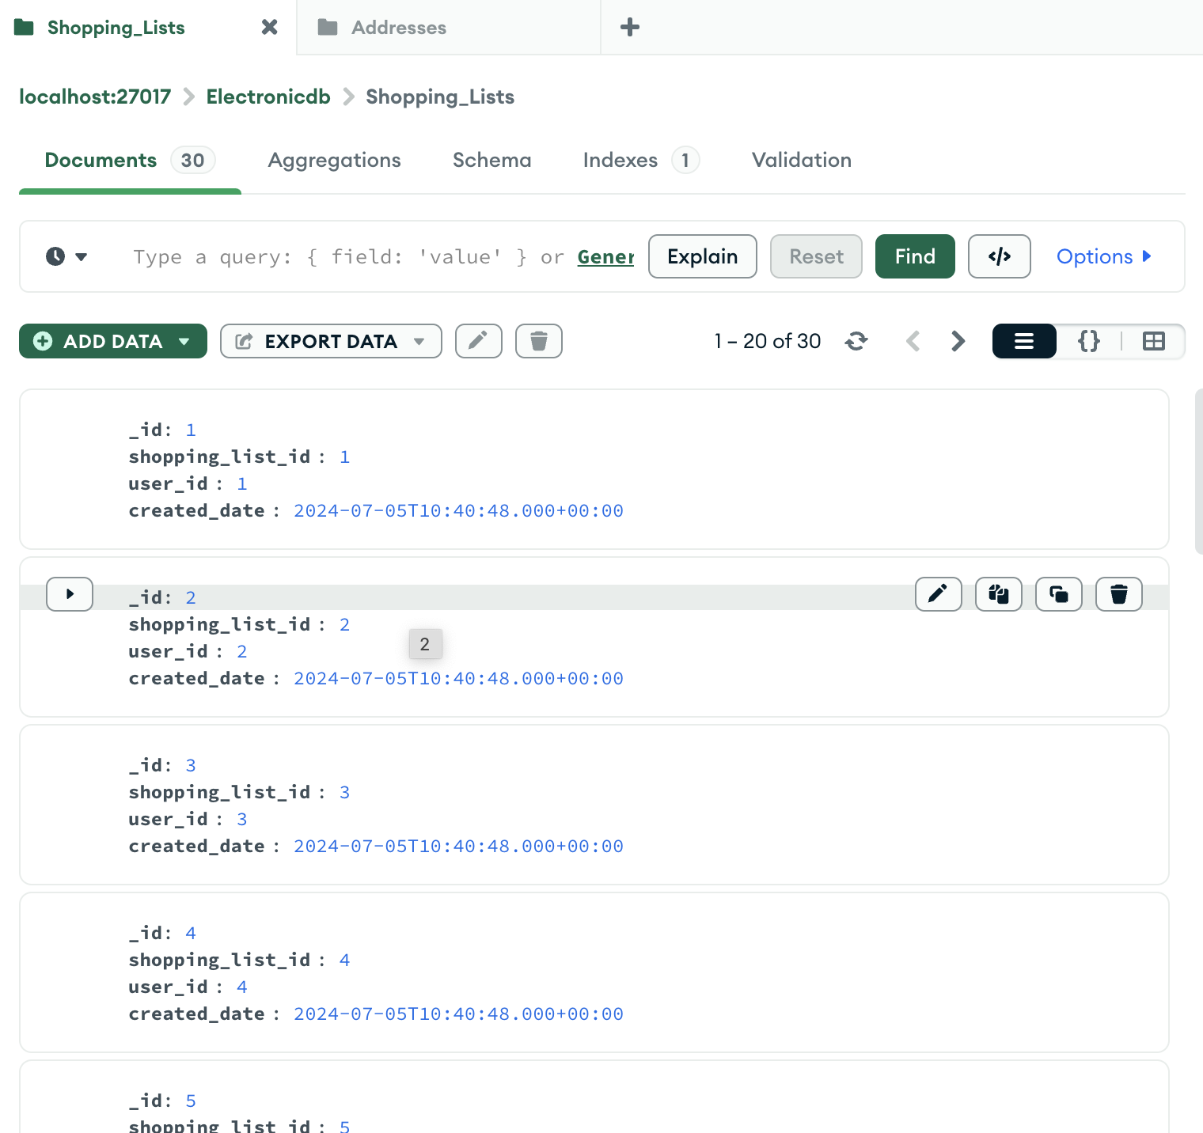 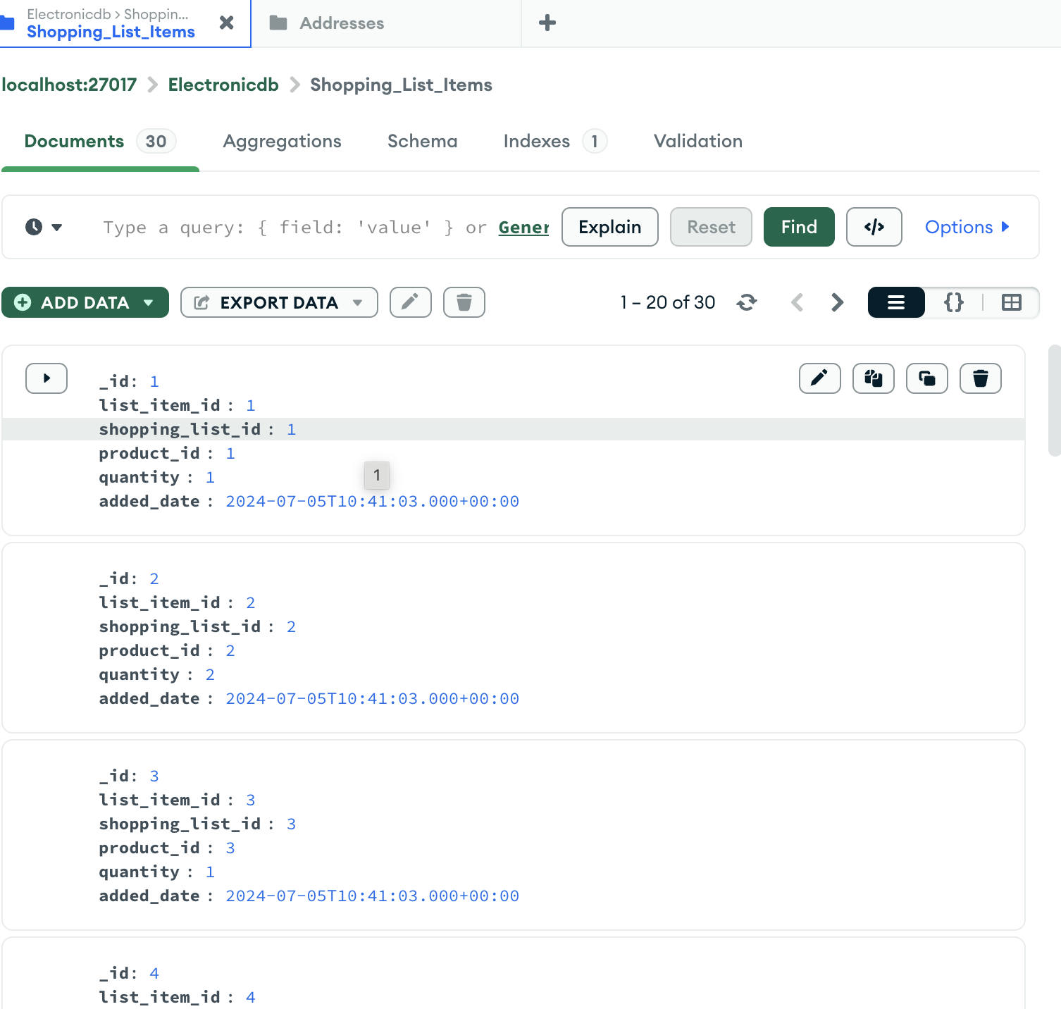

1. Addresses Table

### USER INTERFACE DESIGN

Shopping List – Screen 1

To Retrieve Shopping Lists and Items for a Particular User

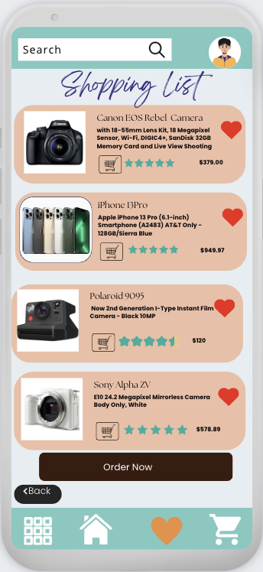 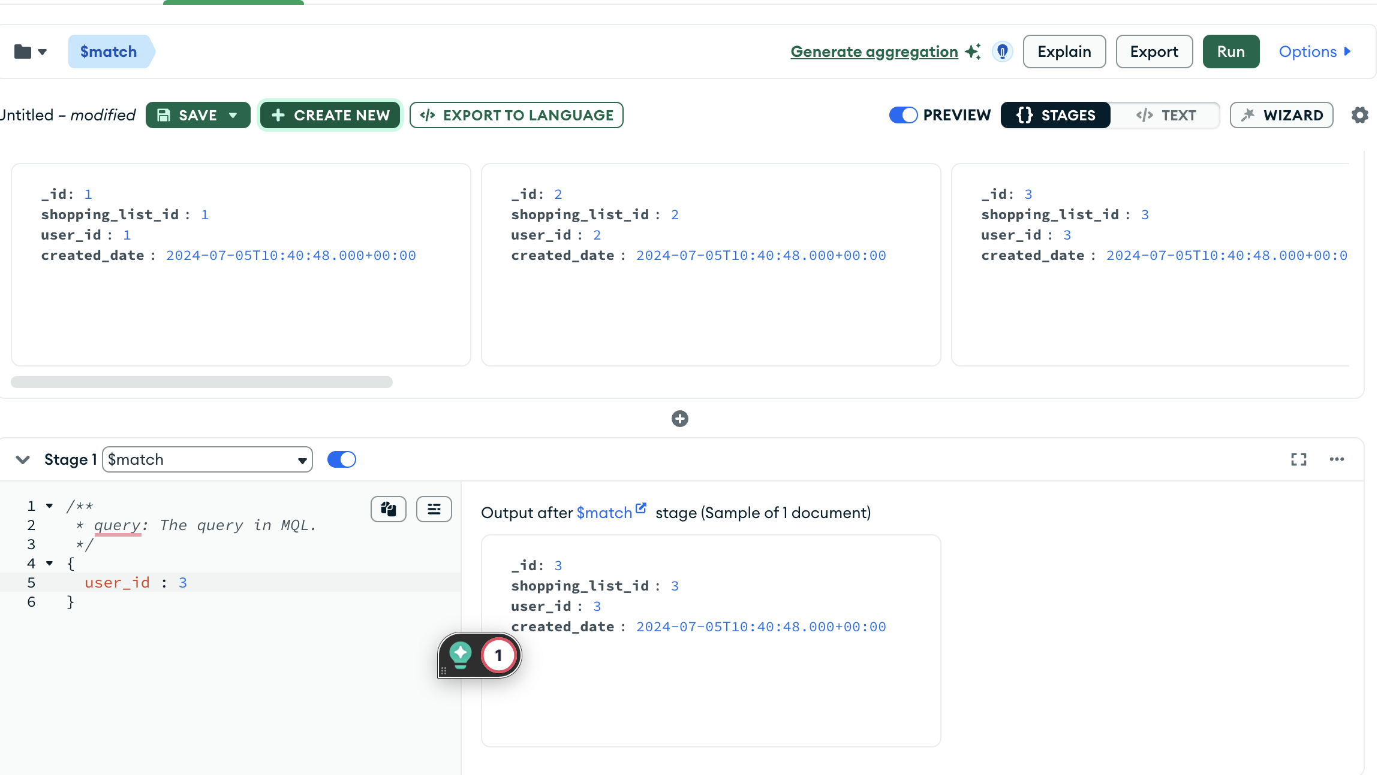

# **DATA MIGRATION**

We are using Studio 3T for migrating data from MySQL to MongoDB[4] as it can simplify the process significantly. Studio 3T is a GUI tool for MongoDB that provides a powerful set of features for data migration, among other things.

### Step-by-Step Migration Strategy

1. ***Install Studio 3T***: If you haven't already, download and install Studio 3T from the [*official website*](https://studio3t.com/)

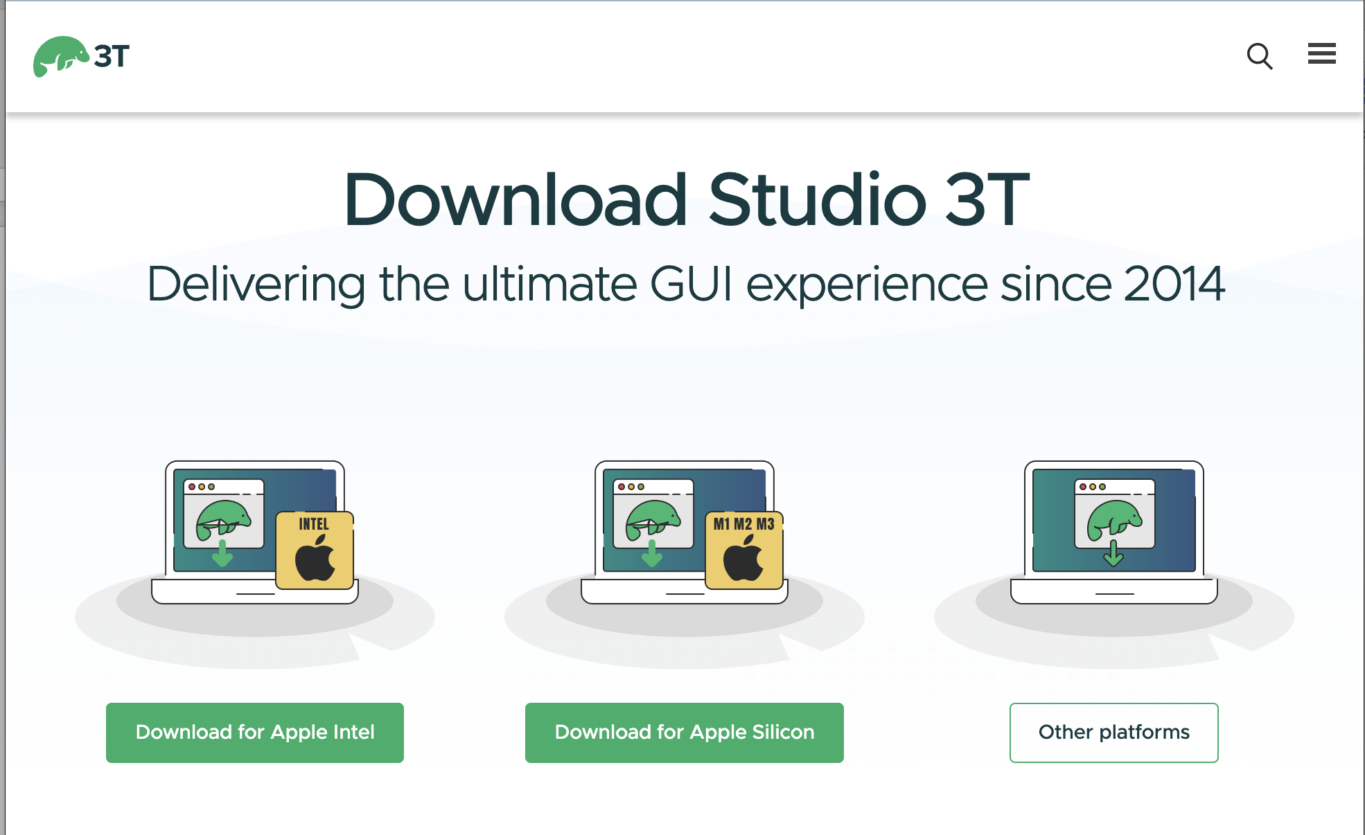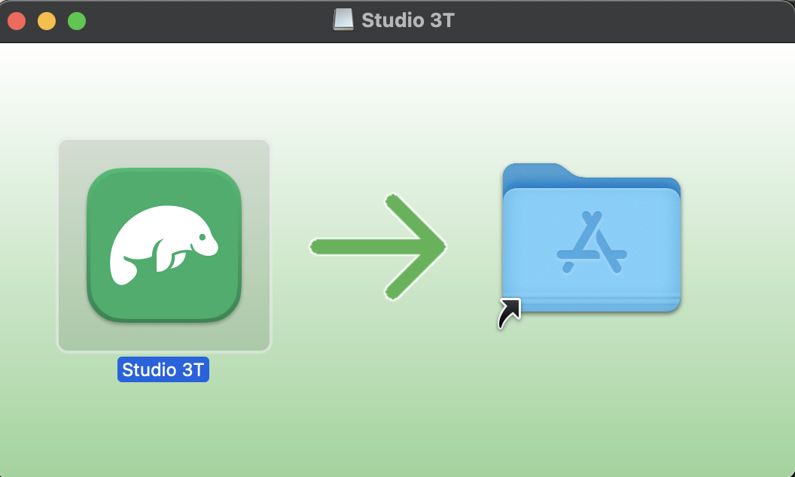

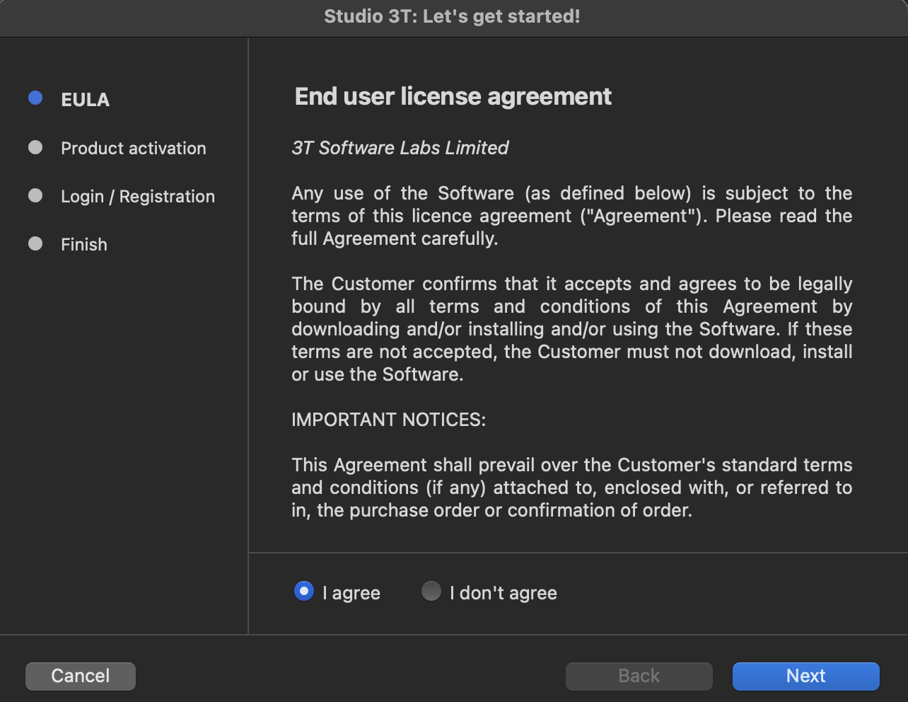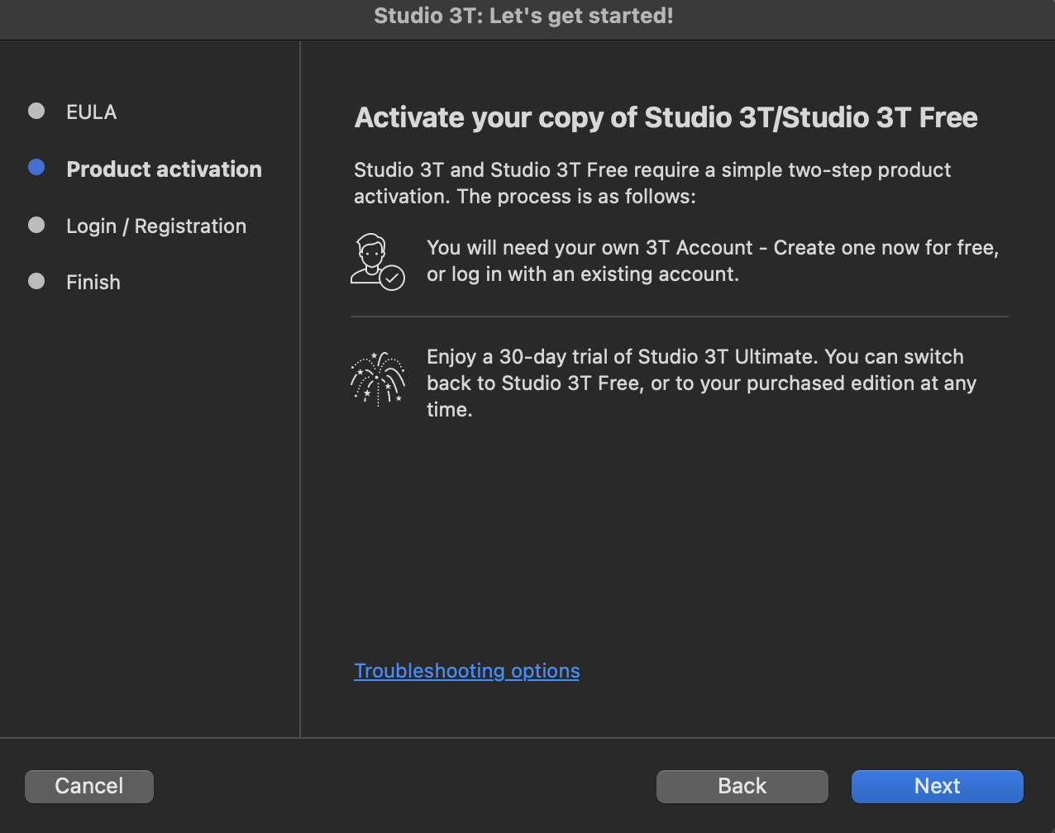

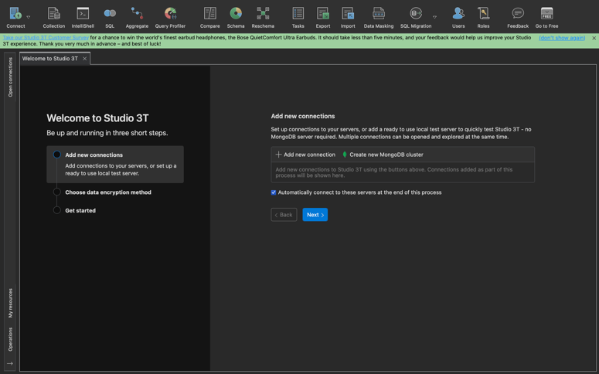

#### 2. **Connect to MySQL**

1. **Open Studio 3T**.
2. **Select Source and Target**:
   * **Source**: Choose your MySQL connection and the database/tables you want to migrate.
   * **Target**: Choose your MongoDB connection and the database/collection where you want the data to go.
3. **Source:**
   * Go to Connect in the toolbar.
   * Click SQL->MongoDBConnection.
   * Choose Source SQL cnnection and fill in the required connection details (host, port, username, password, database).

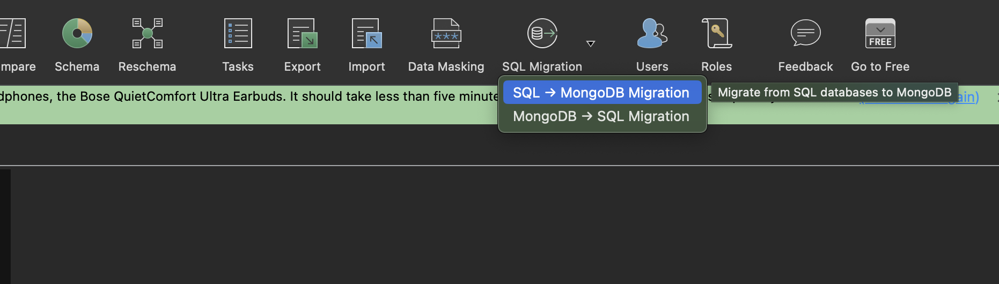

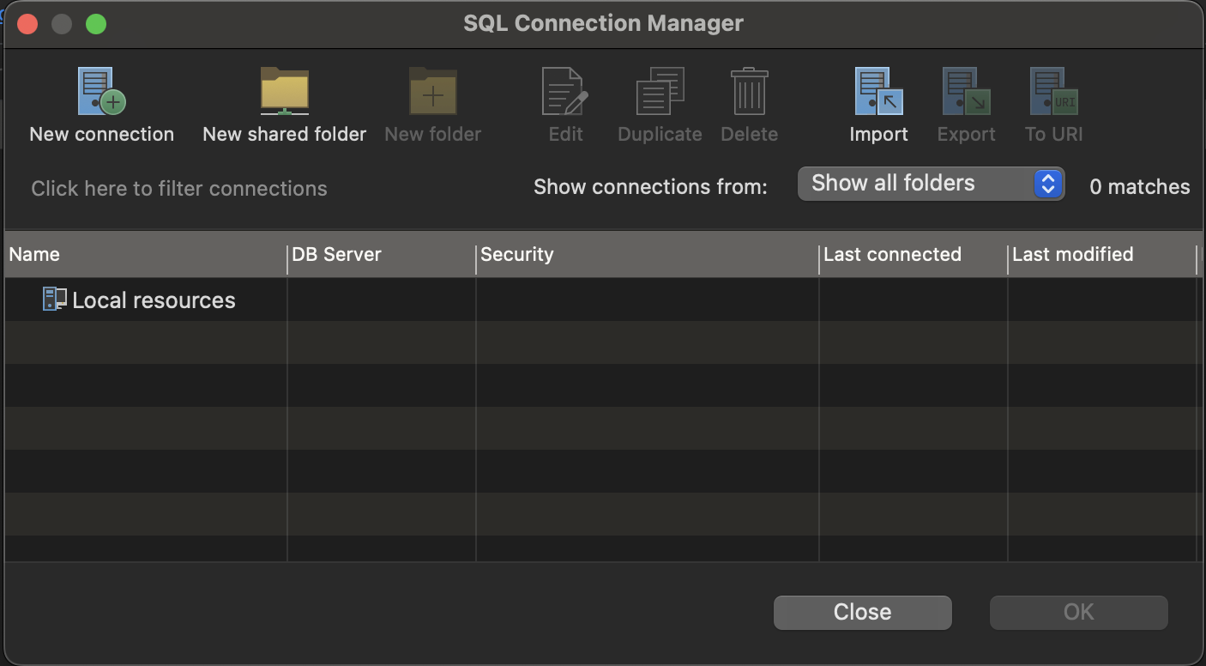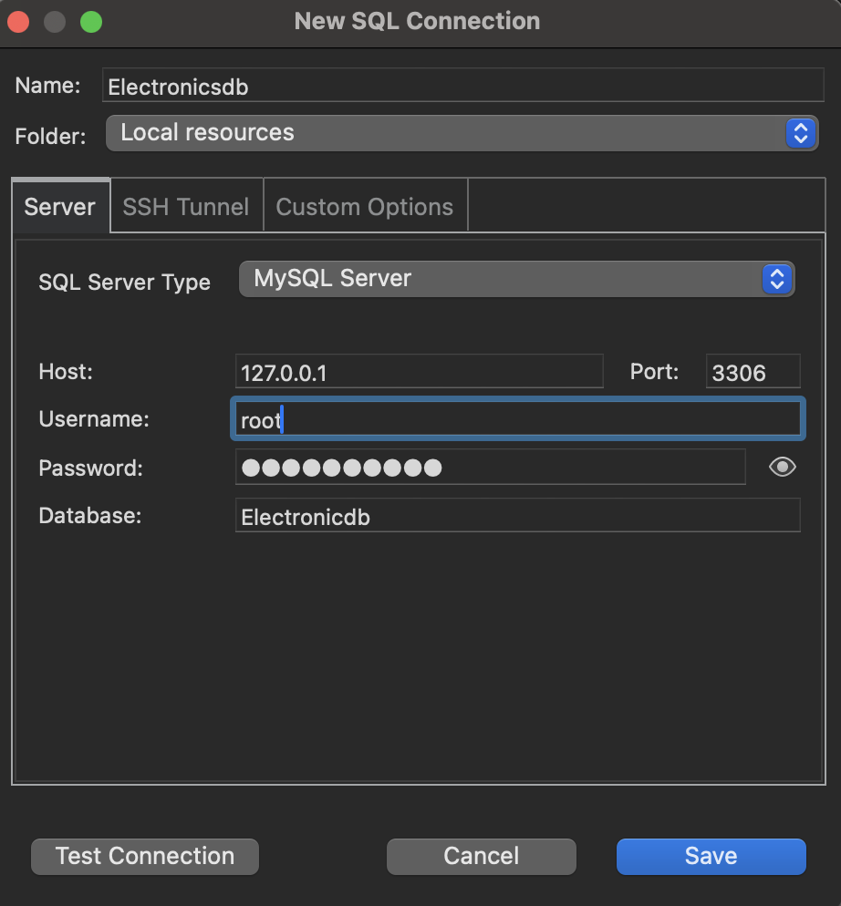

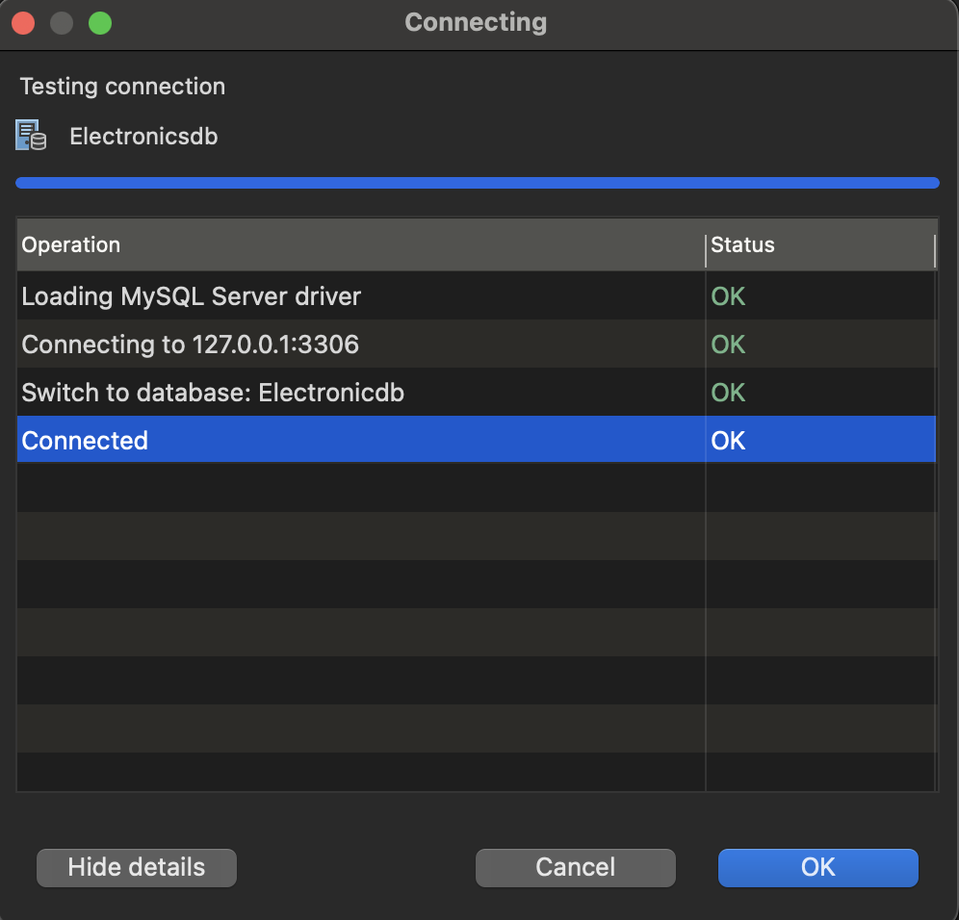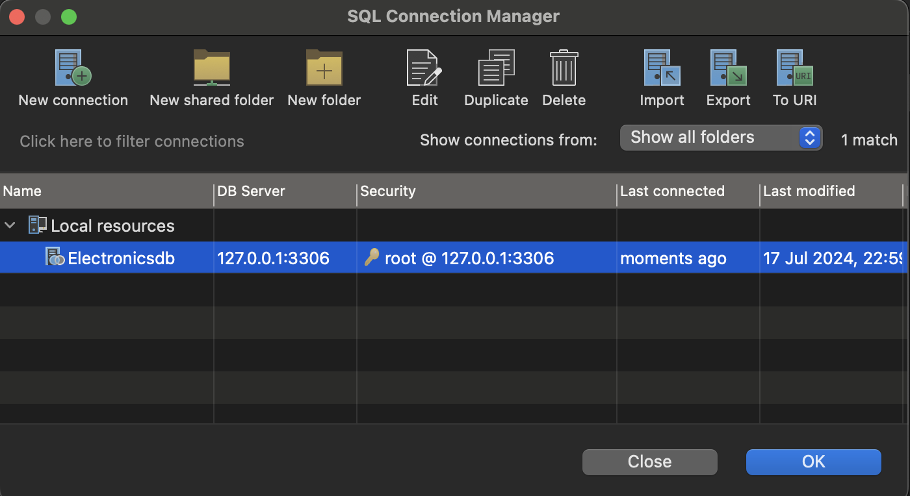

#### 3. **Connect to MongoDB**

1. **Target - MongoDB Connection**:
   * Go to Connect at the Target MongoDBConnection.
   * Fill in the connection details for your MongoDB instance (URL)

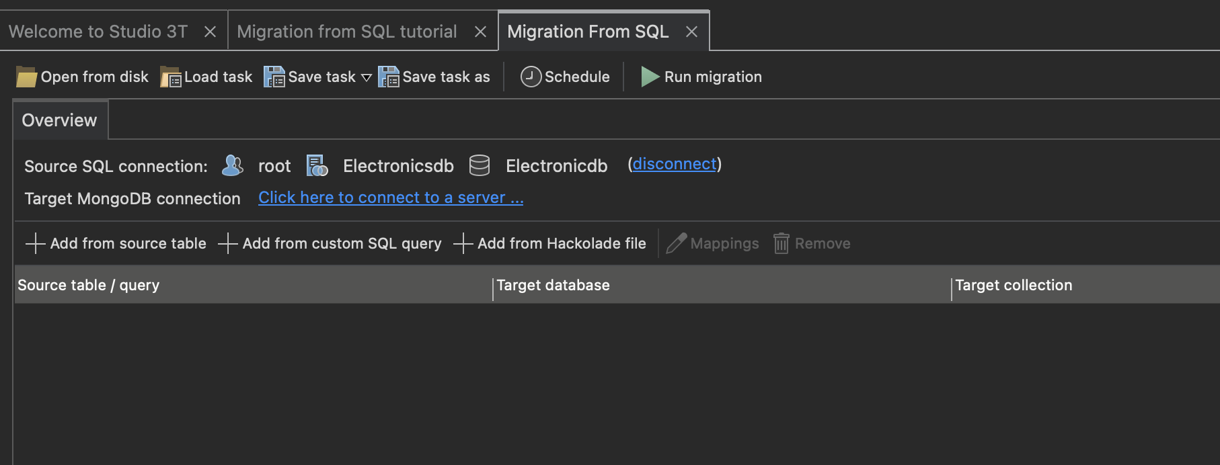

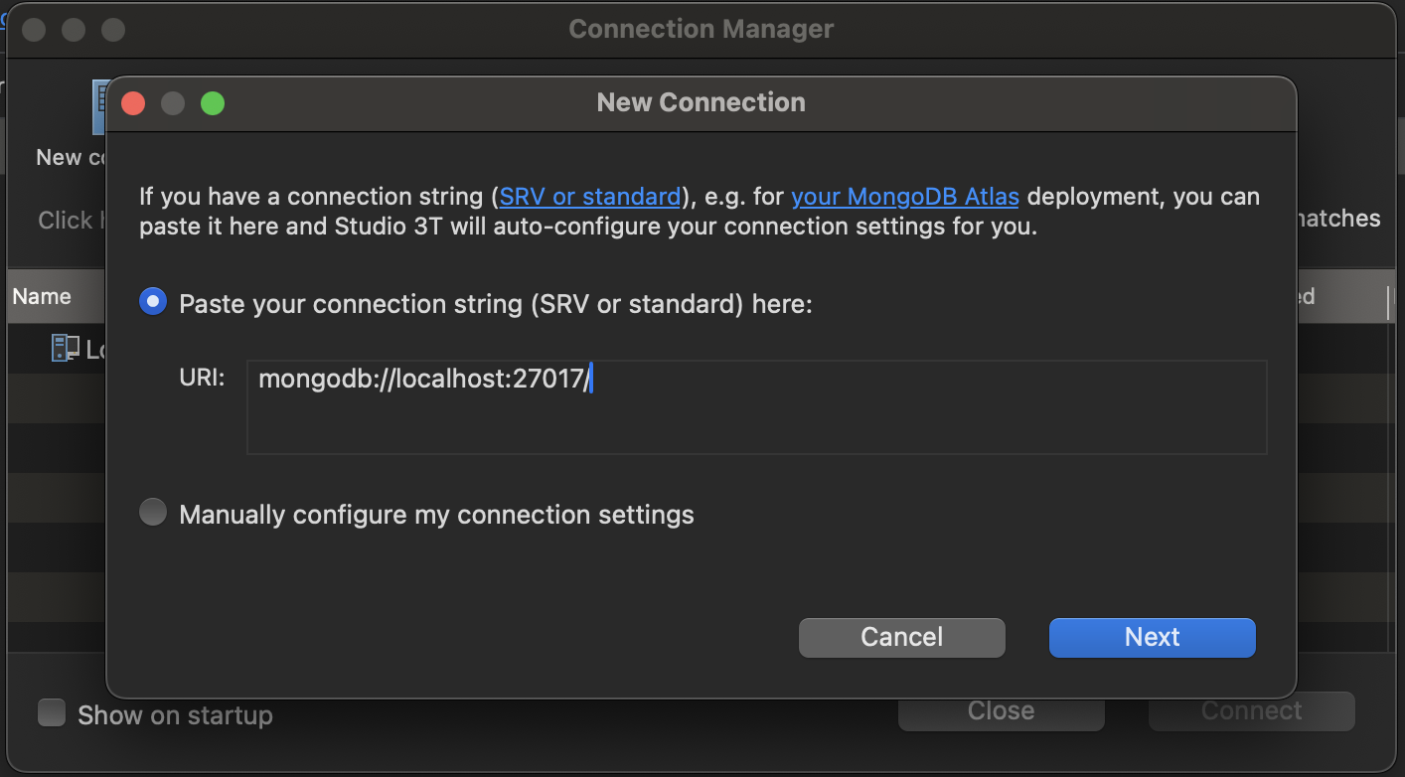

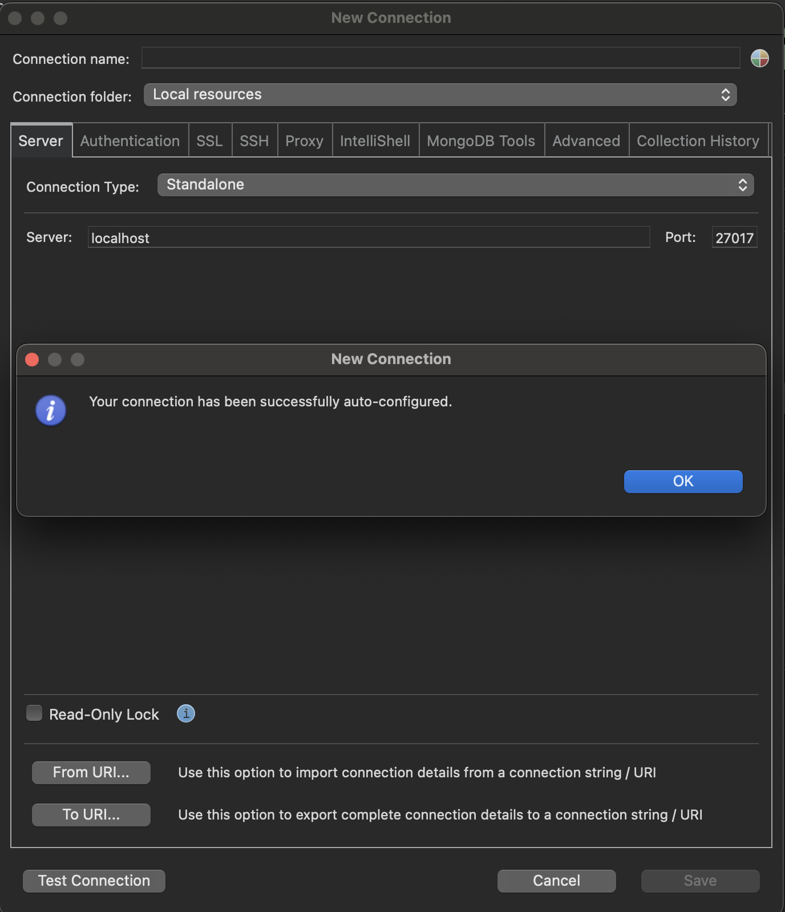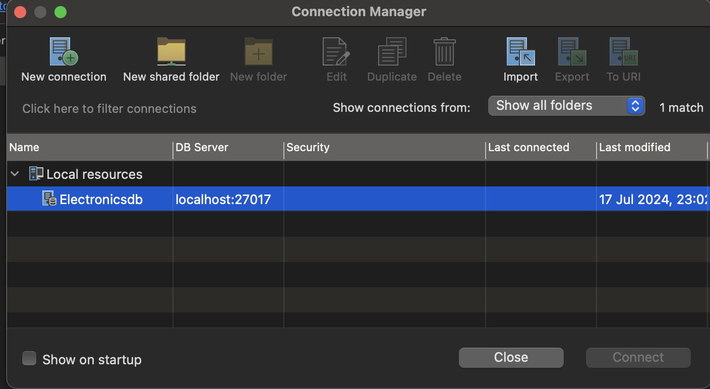

#### 4. **Data Mapping and Transformation**

1. **Start the SQL to MongoDB Migration**:
   * In Studio 3T, go to the Add from SourceTable.
2. **Map SQL Tables to MongoDB Collections**:
   * Studio 3T allows you to map SQL tables directly to MongoDB collections. You can choose to rename collections and customize the mapping.
3. **Transform Data**:
   * Use Studio 3T’s transformation capabilities to adjust the data structure if needed. For example, you can flatten nested objects, change data types, or rename fields.

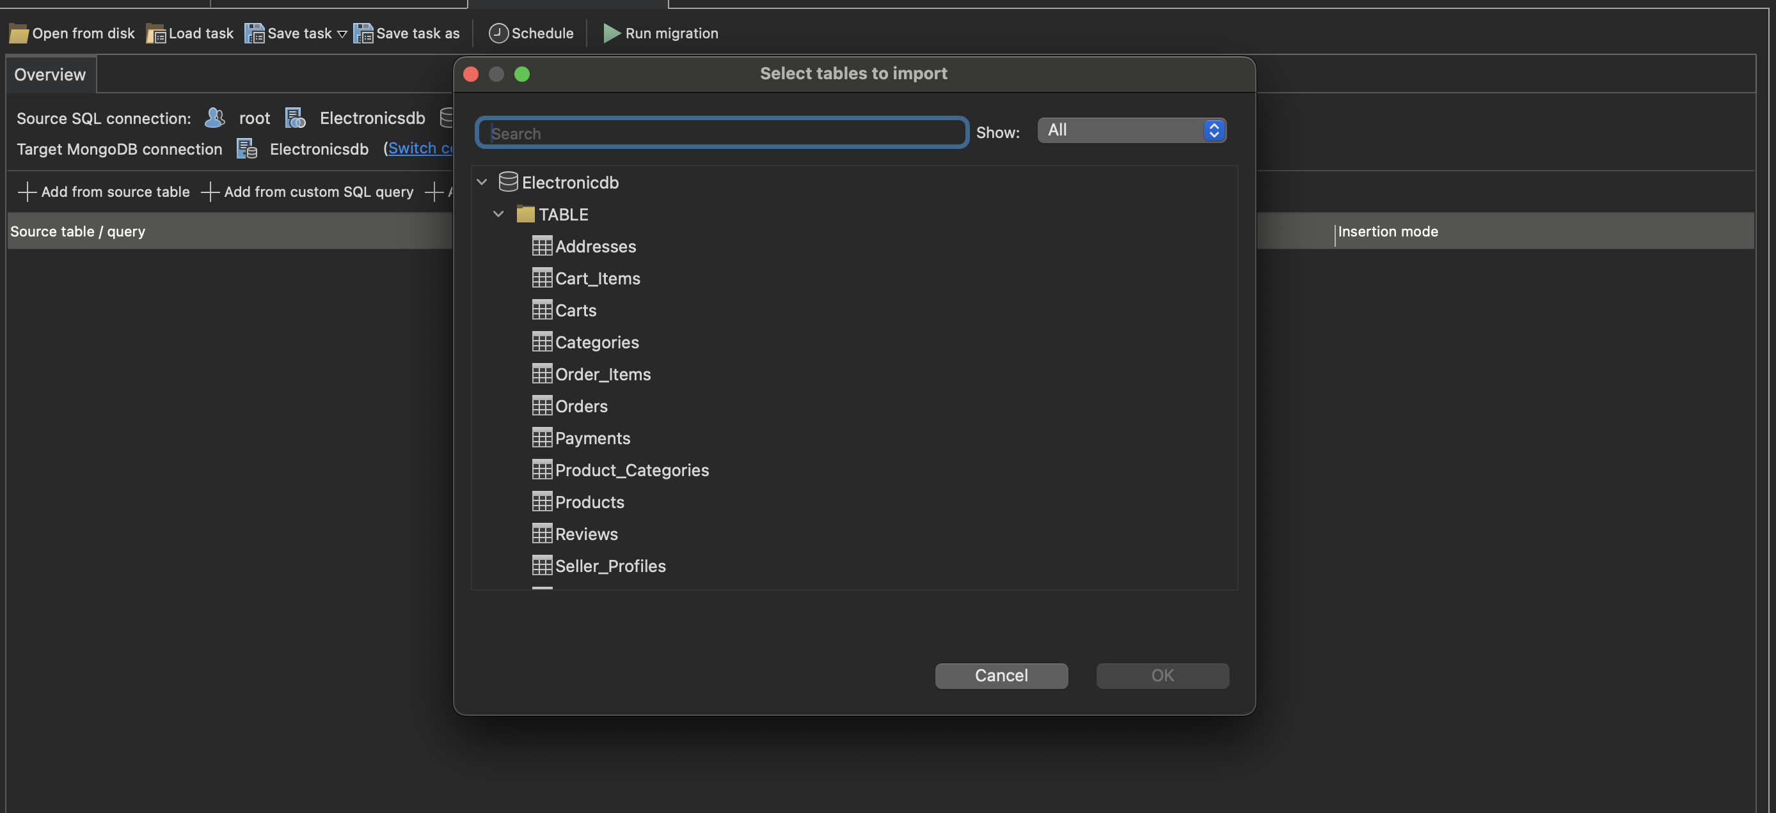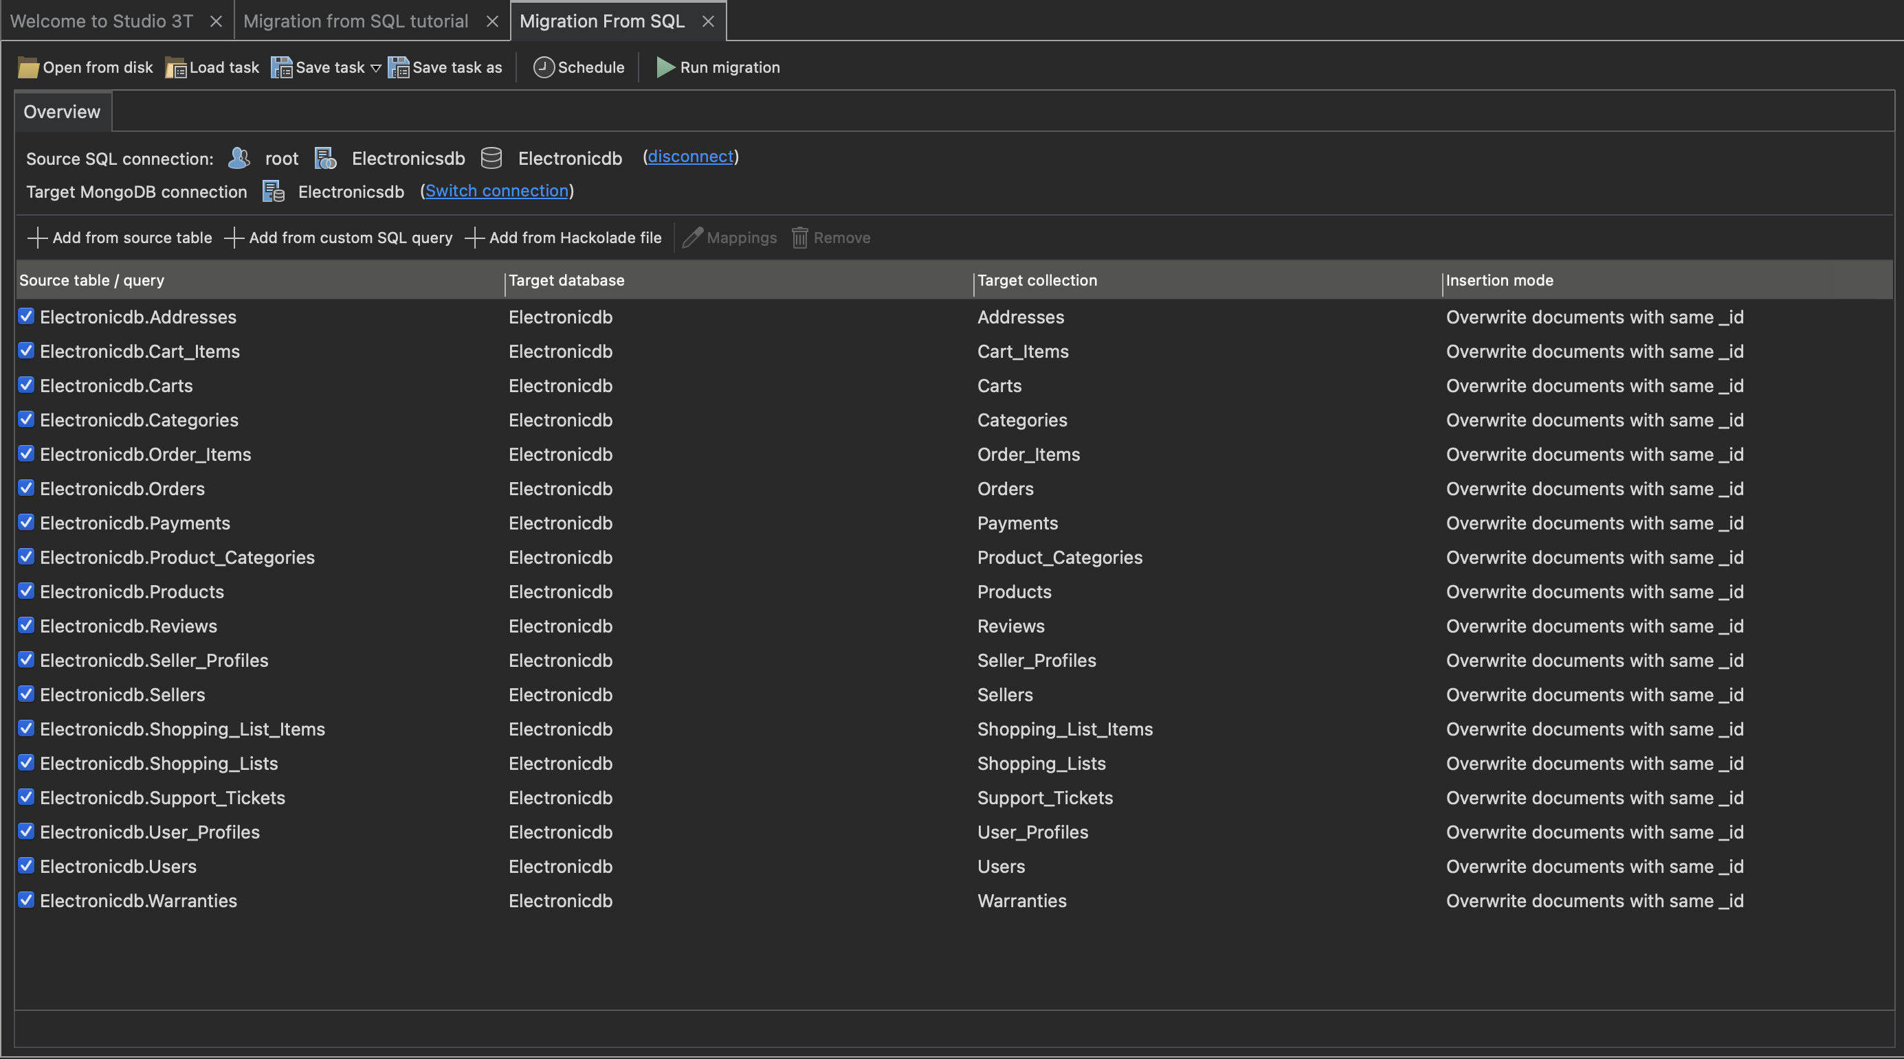

#### 5. **Execute Migration**

1. **Review and Execute**:
   * Review the mapping and transformation settings.
   * Click Run Migration to begin the migration process.
2. **Monitor Progress**:
   * Studio 3T will show the progress of the migration. Depending on the size of your data, this could take some time.

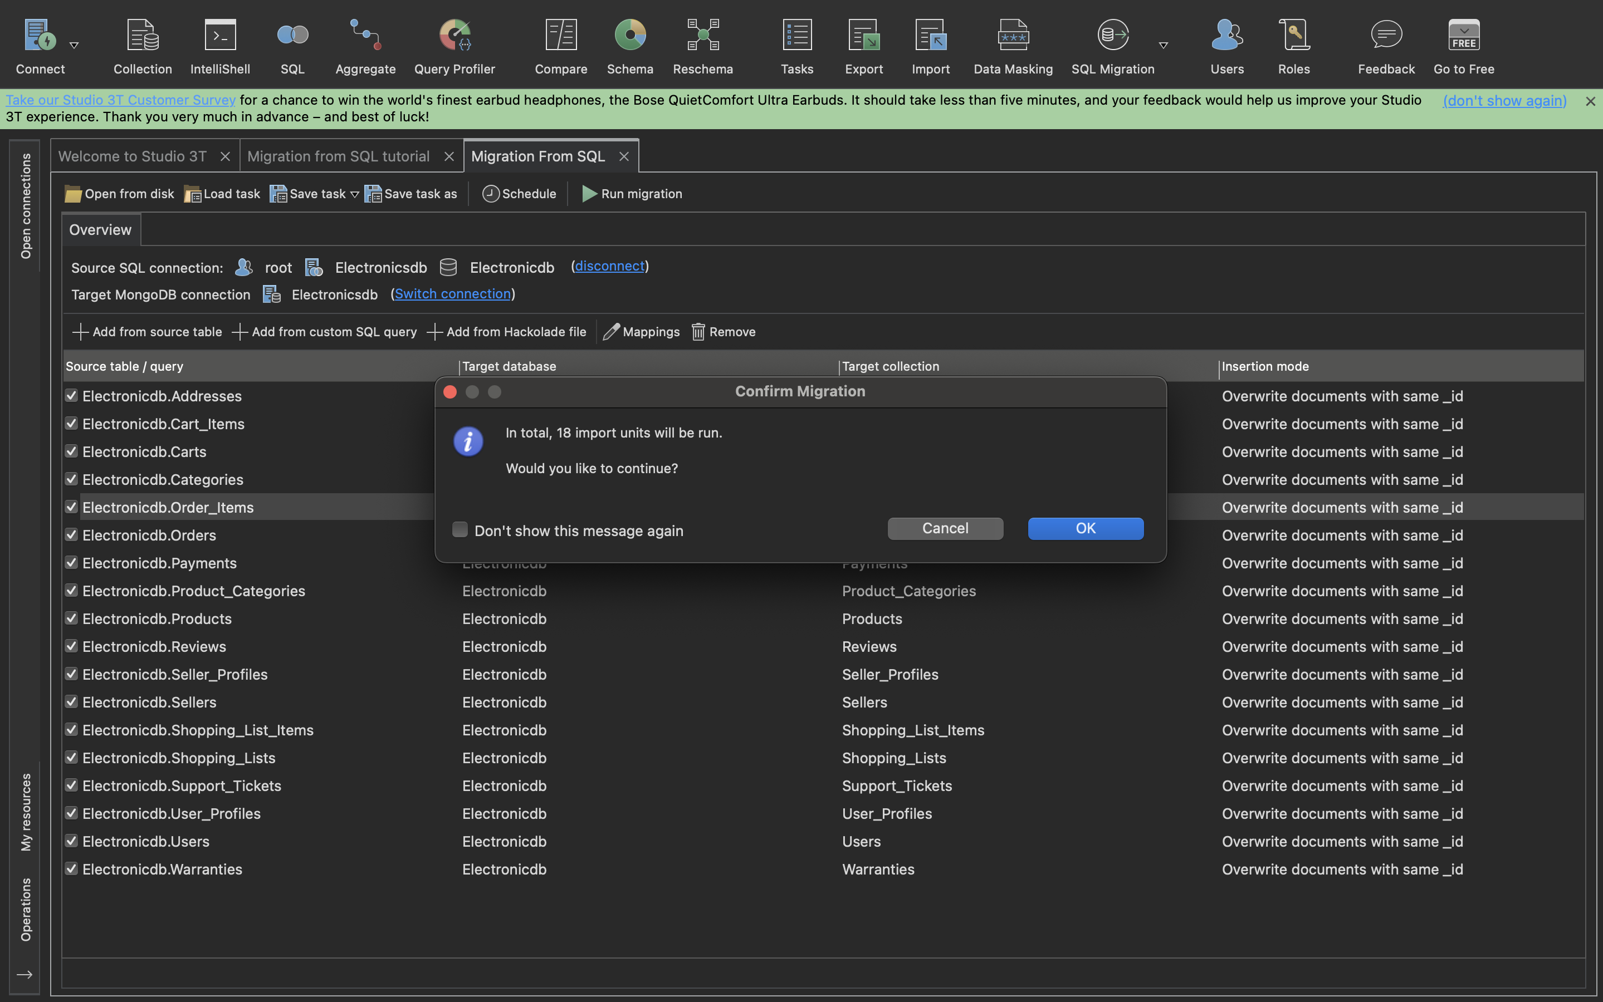

1. **Verify Data**:
   * After the migration completes, verify that the data has been correctly migrated to MongoDB. Check the documents in your MongoDB collections to ensure the structure and content are as expected.

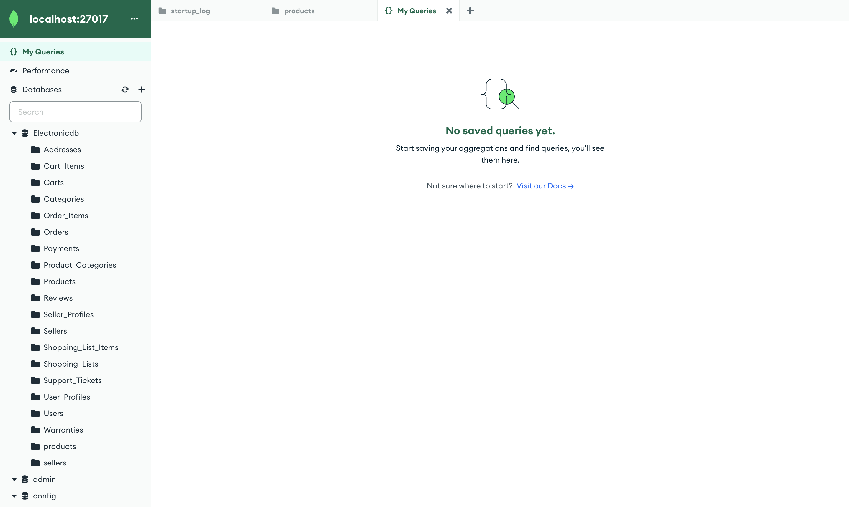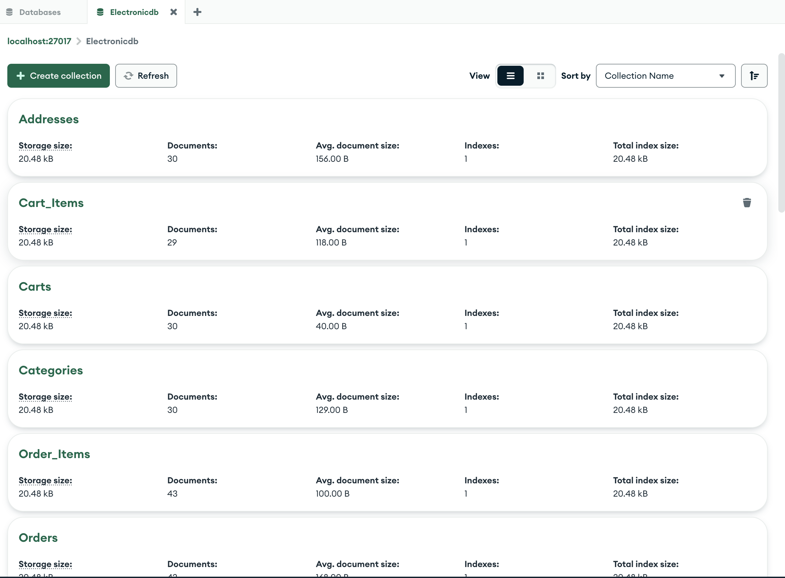

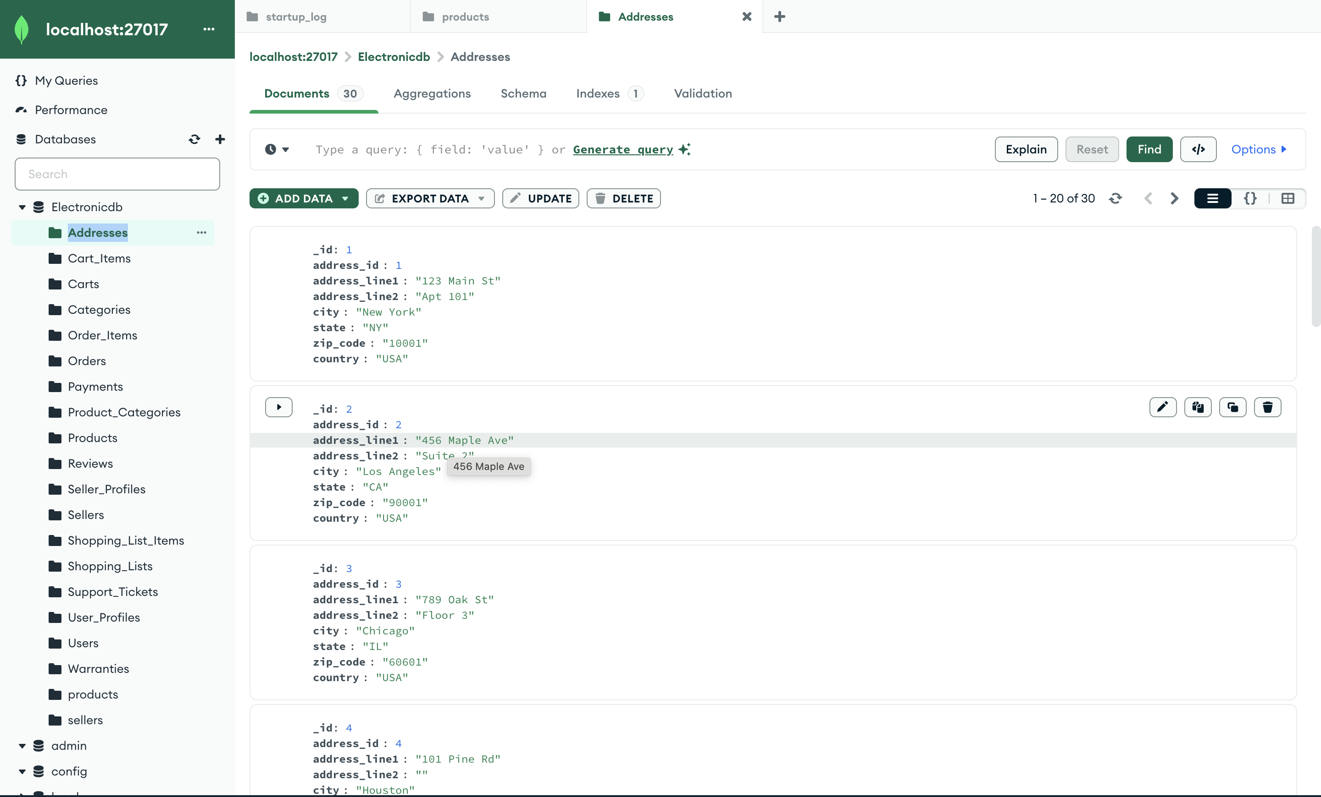

# **Product Listings and Search in MongoDB**

In any e-commerce application, product listings and search functionalities are important for providing a good user experience. MongoDB, with its flexible schema and powerful querying capabilities, is well-suited for implementing these features. For our project we have implemented the below techniques

### Indexing for Search

To enhance search performance, create indexes[3] on fields that are frequently queried.

#### **Create Indexes:**

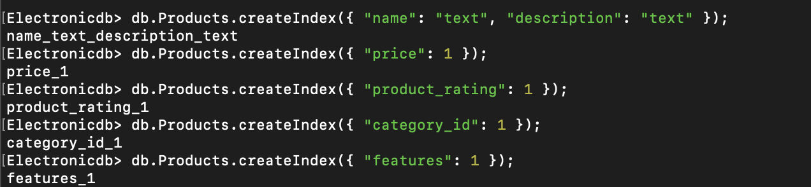

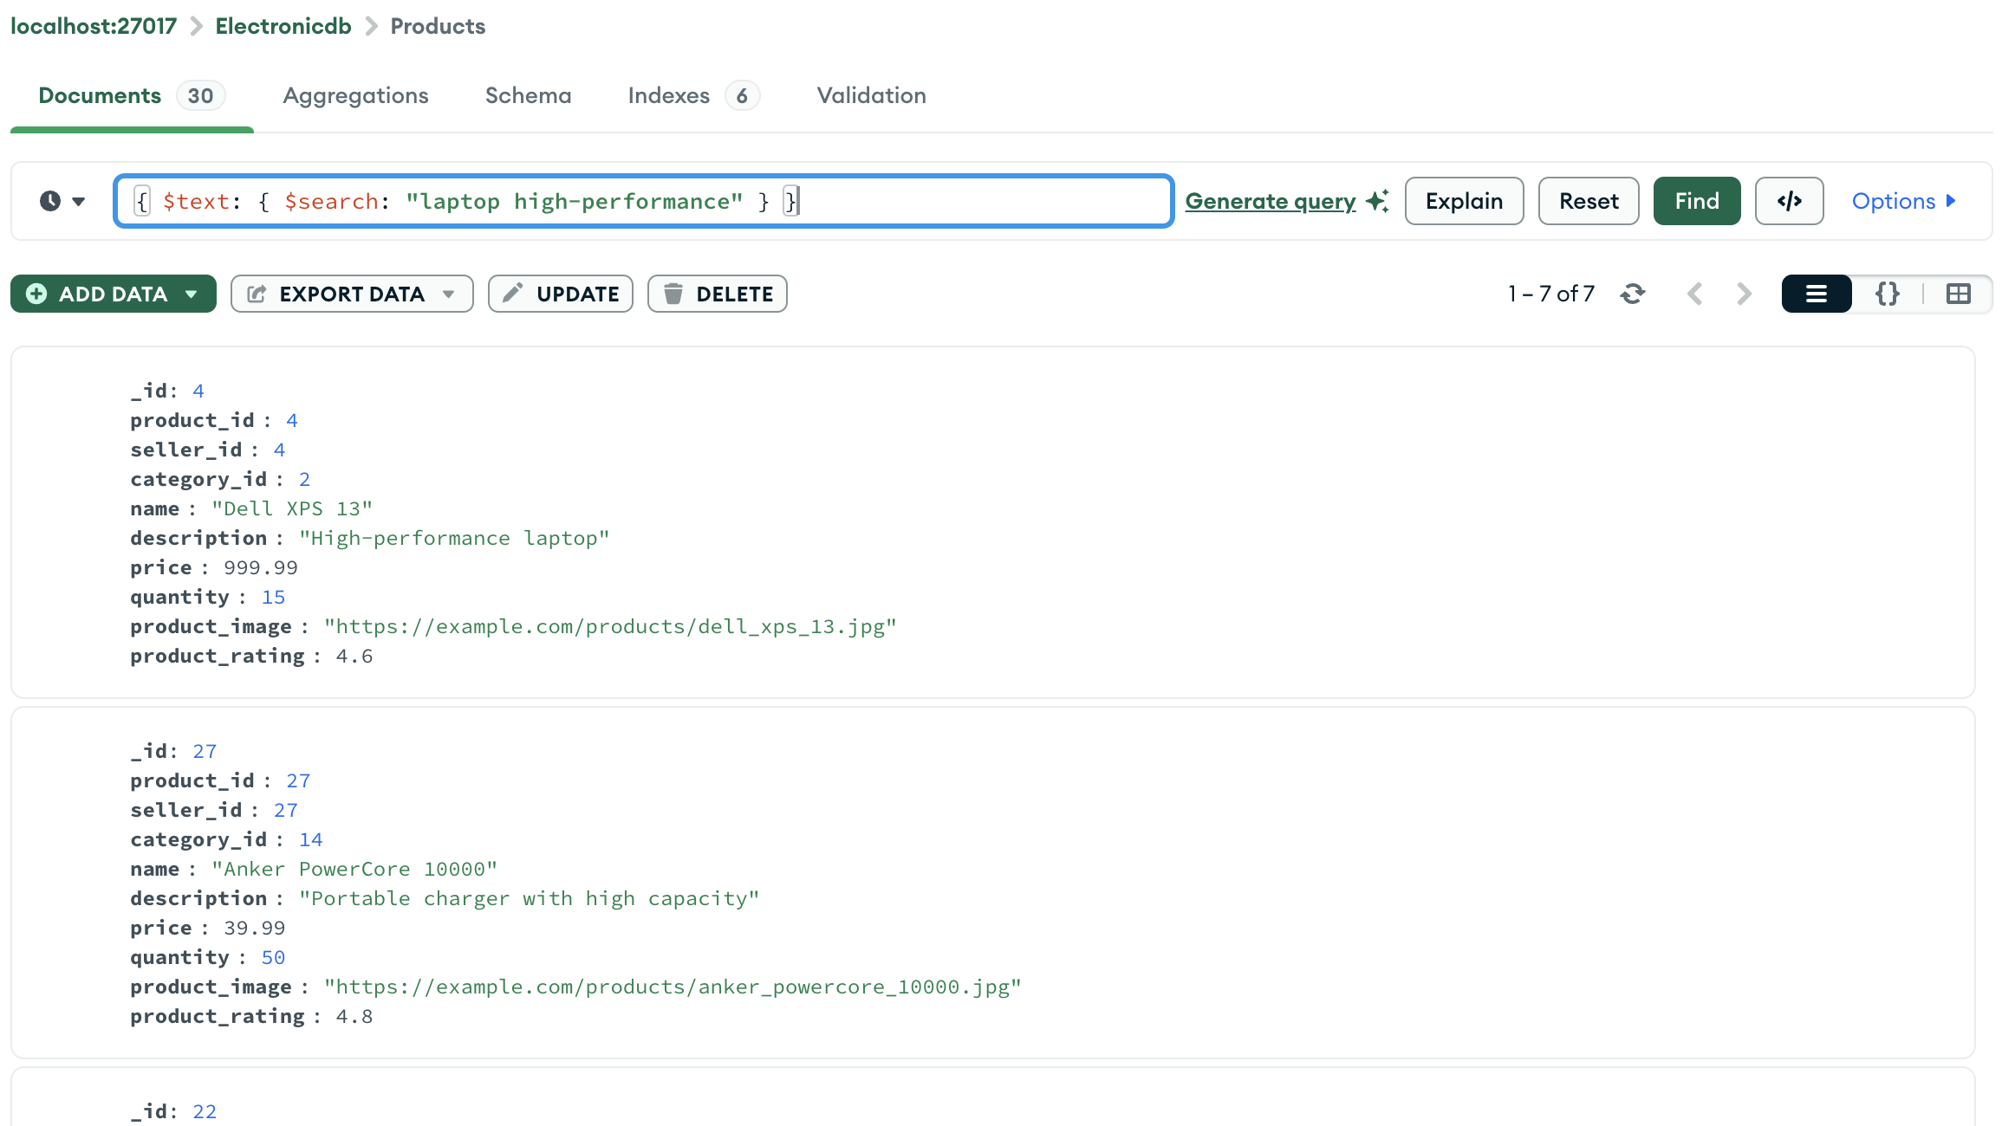

### Search Functionality

#### **Text Search:**

Text search allows users to search for products based on keywords in the name and description.

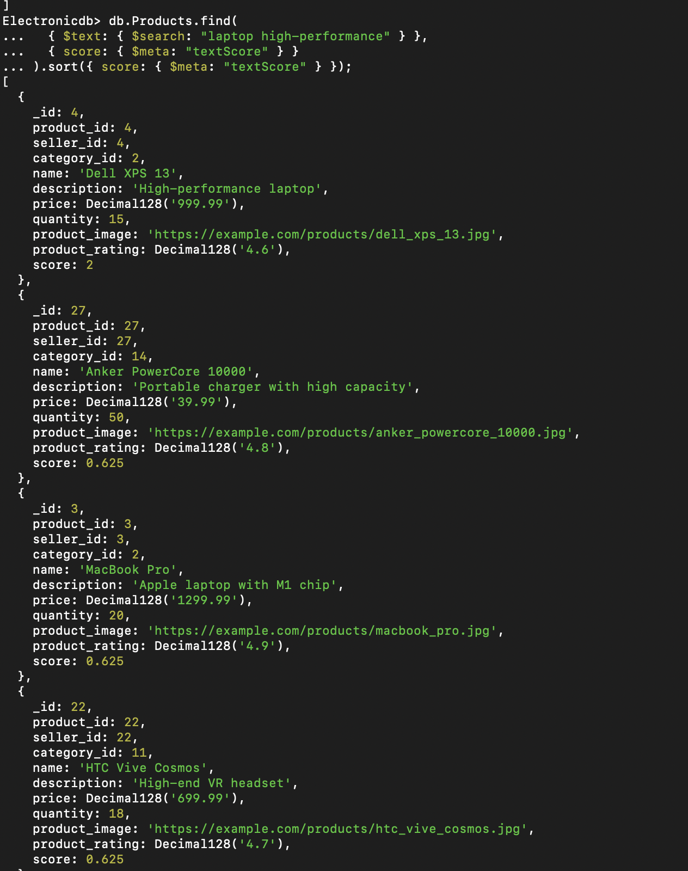

#### **Filter by Price:**

Allow users to filter products by price range.

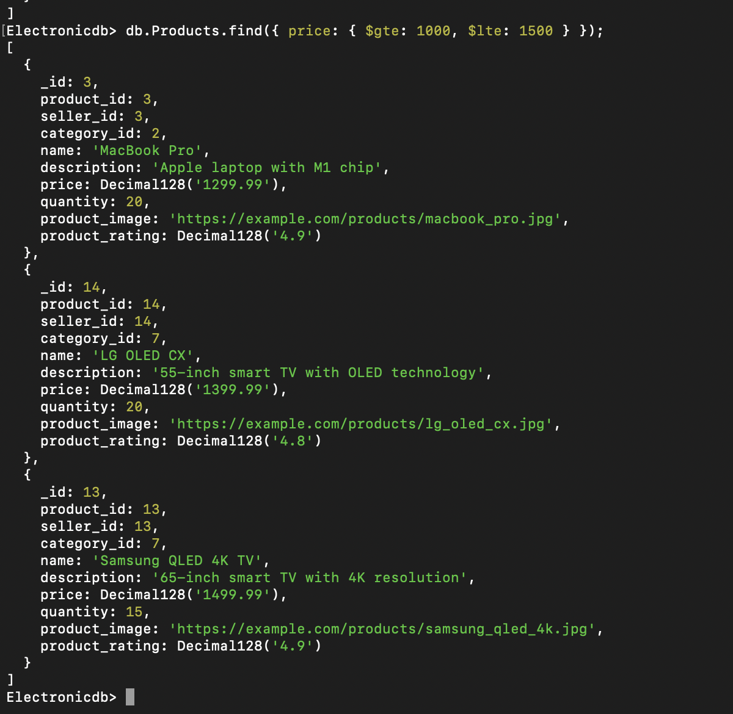

#### **Sort by Rating:**

Allow users to sort products by their ratings.

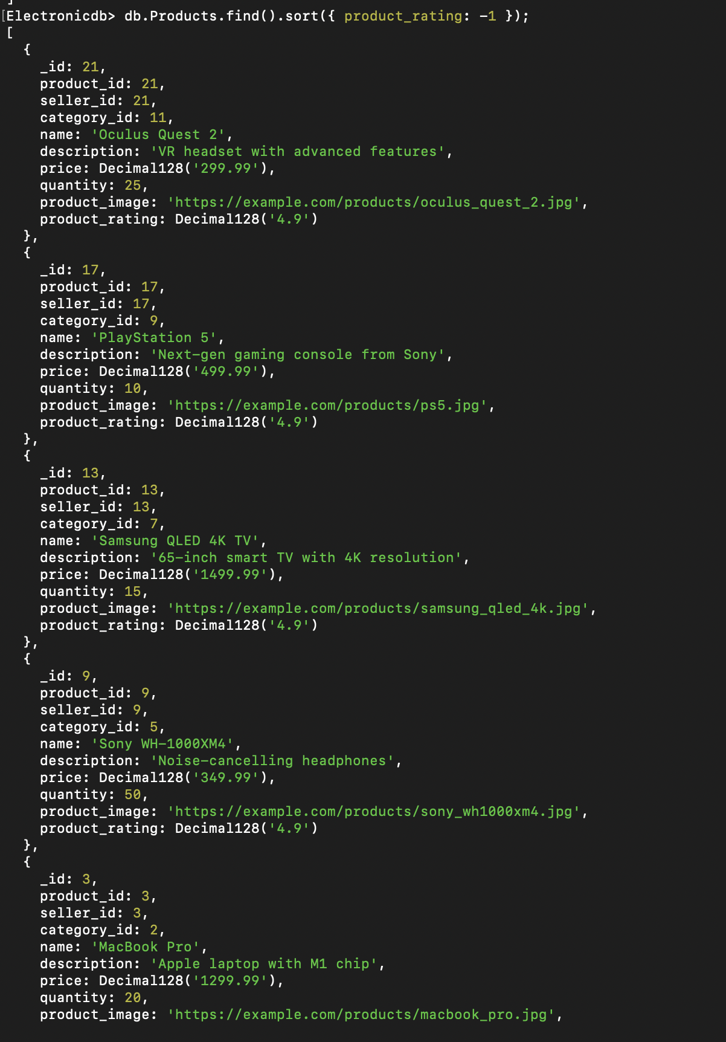

# Data Consistency and Integrity in MongoDB

In our project we ensured data consistency and integrity with the help of MongoDB. By adding these to our project.

### 1. **Data Consistency**

Data consistency refers to ensuring that data remains accurate and consistent across the database. MongoDB ensures consistency using:

#### **Atomic Operations**

* **Single-Document Atomicity**: In MongoDB, all write operations on a single document are atomic. This means that no matter how many fields are being updated in a single document, the operation will either complete fully or not at all, preventing partial updates.

db.collection.updateOne(

{ _id: 1 },

{

$set: { field1: "value1", field2: "value2" },

$inc: { field3: 1 }

}

);

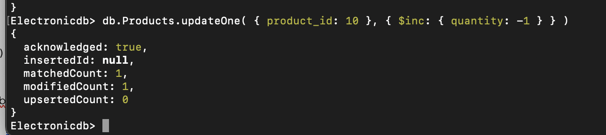

### 2. **Data Integrity**

Data integrity ensures that data is accurate and reliable. MongoDB provides several features to maintain data integrity:

#### **Schema Validation**

* **JSON Schema Validation**: MongoDB allows schema validation at the collection level. This ensures that documents adhere to a defined structure, enforcing field types, required fields, and other constraints.

##### Explanation of JSON Structure

* **_id Field**: The unique identifier for the document. Specified using the $oid format to indicate an ObjectId.
* **user_id Field**: Integer, required.
* **username Field**: String, required.
* **password_hash Field**: Binary data in Base64 format. Specified using the $binary format with base64 and subType properties.
* **email Field**: String, must be a valid email address, required.
* **contact_details Field**: String, optional.
* **user_image Field**: String, optional.
* **address_id Field**: Integer, optional.
* **payment_info Field**: String, optional.

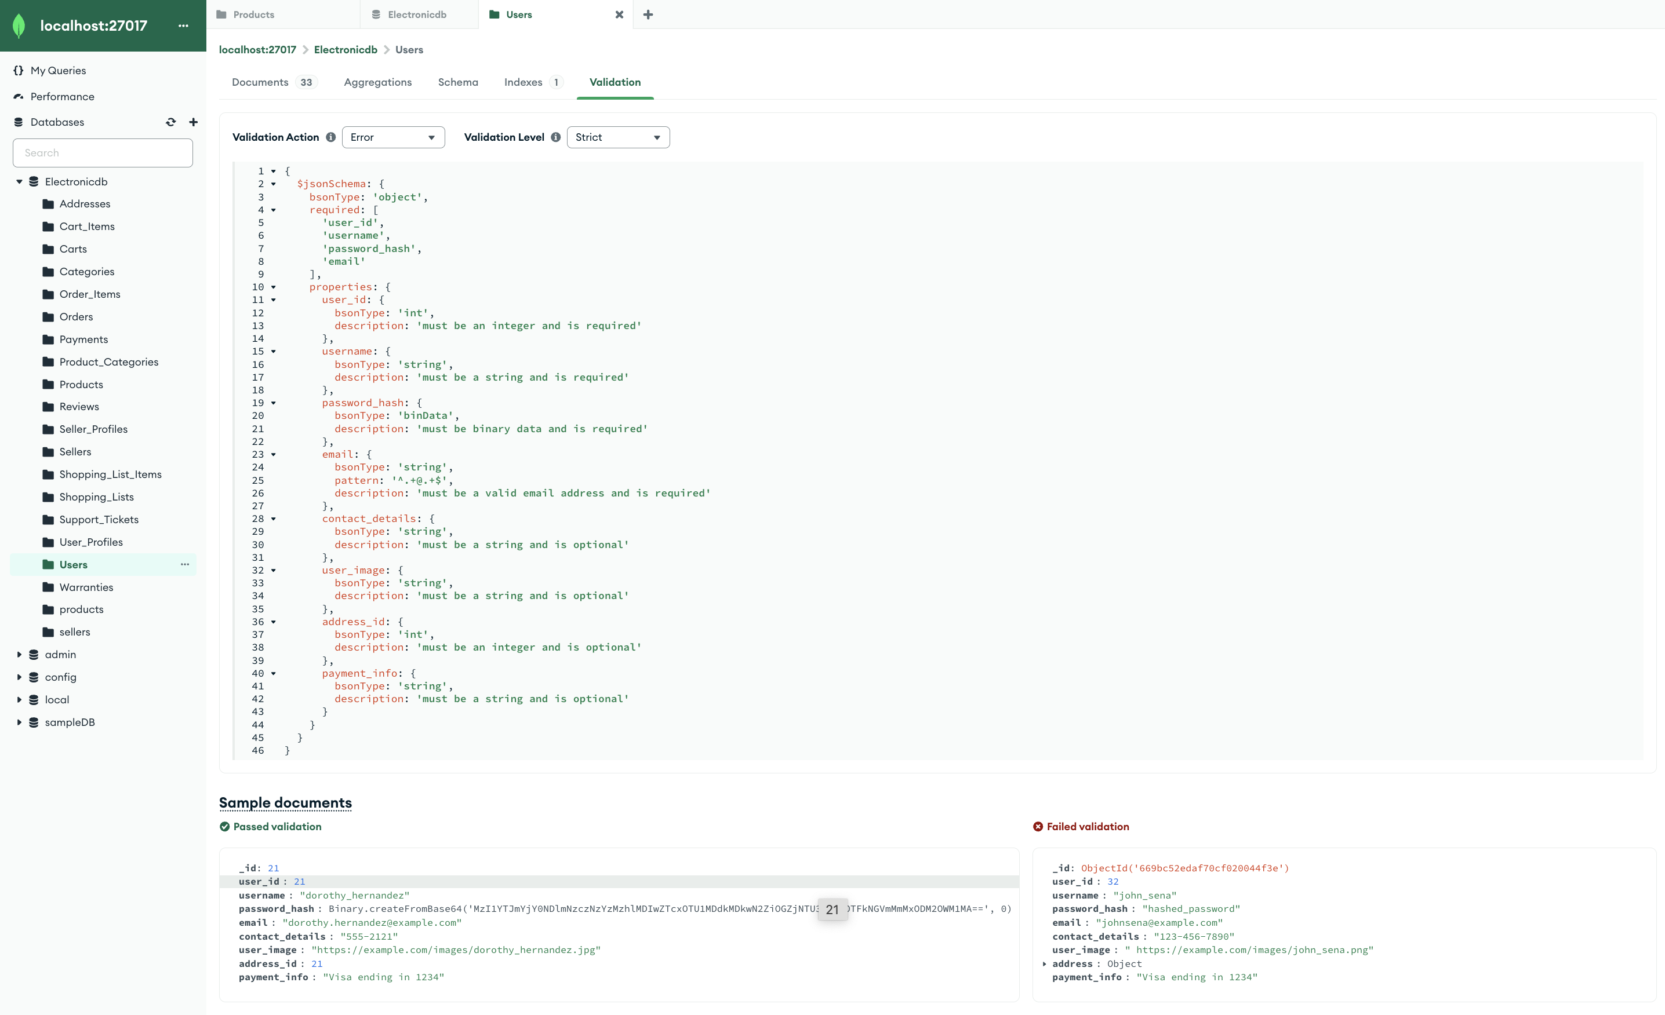

Screenshots of failed and success validation of users when inserting a collection (Hashed Password)

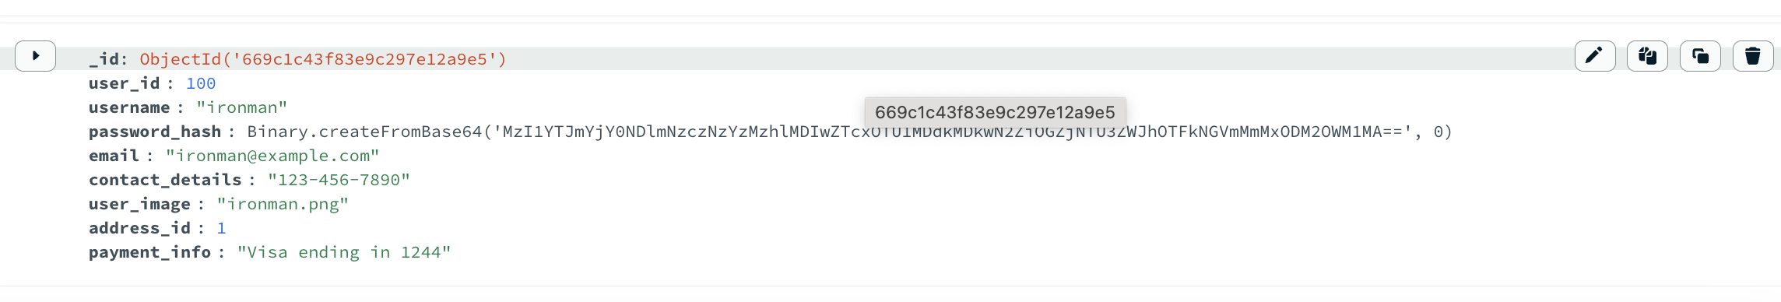

#### **Indexes**

* **Unique Indexes**: MongoDB supports unique indexes, which ensure that the indexed field does not have duplicate values across documents in the collection. This is important for maintaining data integrity in fields that require uniqueness, such as email addresses or user IDs.

### 

### 3. **Data Durability**

Data durability ensures that once an operation is acknowledged, it will persist even in the event of a failure. MongoDB uses several mechanisms to achieve this:

#### **Write Concern**

* **Write Concern Levels**: MongoDB allows configuring write concern, which determines the level of acknowledgment requested from MongoDB for write operations. Higher write concern levels can provide greater assurance of data durability.

By configuring write concern levels appropriately, you can control the balance between performance and data durability based on the criticality of the data. For the products collection, which might contain crucial inventory data, a higher write concern level ensures data is not lost.

#### **Journaling**

* **Journaling**: MongoDB uses journaling to provide durability. Journaling records write operations in a journal file before applying them to the data files. In the event of a crash, MongoDB can use the journal to recover and ensure data consistency.

# Scalability and Performance testing

#### Index Application

The implementation of the price_1 index on the Price field within the products collection was validated. The explain output confirmed that the index is actively being utilized for range queries filtering products within specific price brackets.

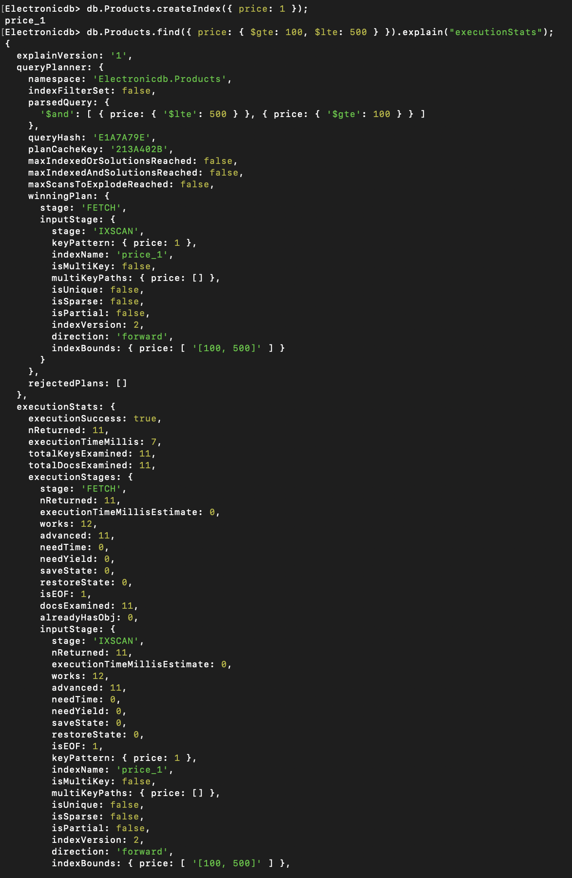

The implementation of the price_1 index and its active utilization for range queries demonstrates significant improvements in query performance. The IXSCAN operation efficiently narrows down the result set using the index, while the FETCH stage retrieves the relevant documents. This optimized query path reduces unnecessary scans of the entire collection, ensuring faster and more efficient query execution[2] . By using indexes, MongoDB can handle larger datasets and higher query loads more efficiently, contributing to the overall scalability and performance of the application. Regular monitoring and analysis of index utilization and query performance are essential to maintain optimal performance as the application scales.

# NoSQL Database Selection

For any project selecting the right NoSQL database[5] for your project involves evaluating various factors including data model requirements, scalability, performance, ease of use, and specific use case needs.

**Types of NoSQL Databases**

|  |  |  |  |
| --- | --- | --- | --- |
|  | Examples | Data Model | Use Cases |
| **Document Stores** | MongoDB, Couchbase | JSON-like documents (BSON in MongoDB) | Content management, e-commerce, user profiles |
| **Key-Value Stores** | Redis, DynamoDB | Key-value pairs | Caching, session management, real-time analytics |
| **Column Stores** | Apache Cassandra, HBase | Wide-column stores (rows and columns) | Time-series data, real-time analytics, big data |
| **Graph Databases** | Neo4j, Amazon Neptune | Nodes, edges, and properties | Social networks, fraud detection, recommendation engines |

# **ANALYTICAL QUERIES**

Analytical queries in MongoDB are used to perform complex data analysis and aggregation tasks. MongoDB provides a powerful aggregation framework[8] that allows you to perform a variety of operations such as filtering, grouping, sorting, and transforming data.

### 1. Total Sales by Product

Calculate the total sales for each product based on order items.

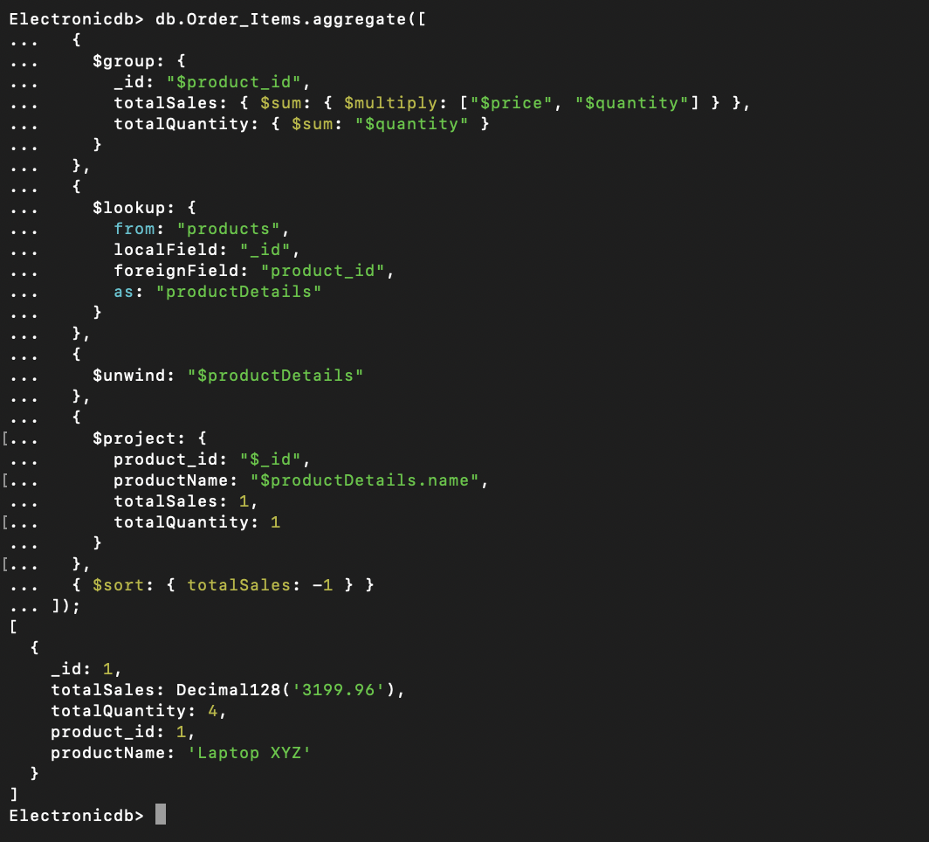

### 2. Average Rating by Product

Calculate the average rating for each product based on user reviews.

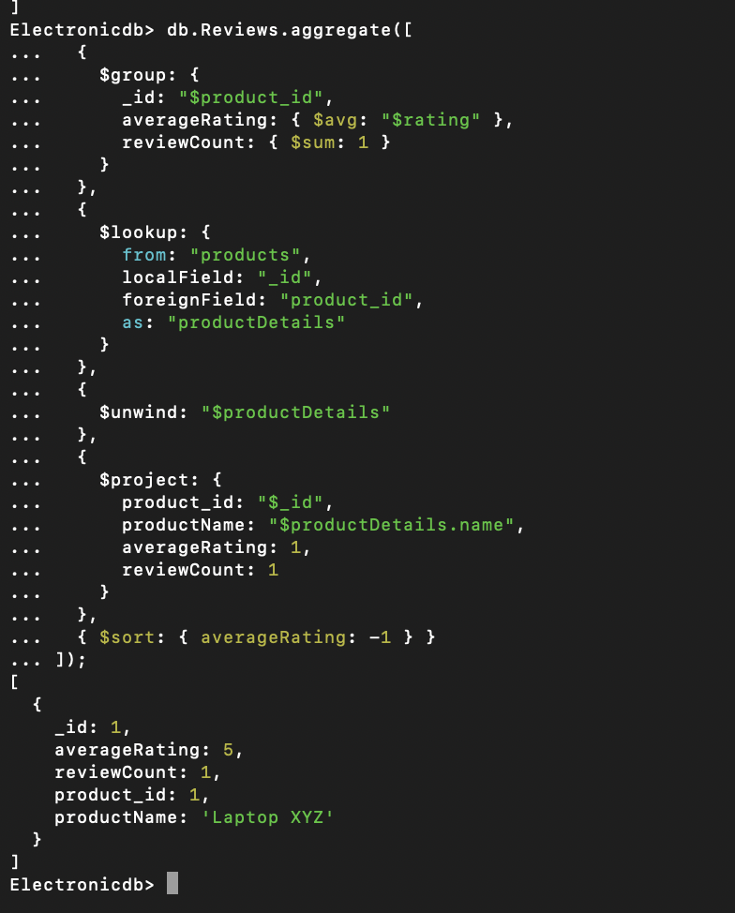

### 4. Top Selling Products

Identify the top 10 selling products based on the total quantity sold.

### 5. Customer Order History

Retrieve the order history for a specific customer.

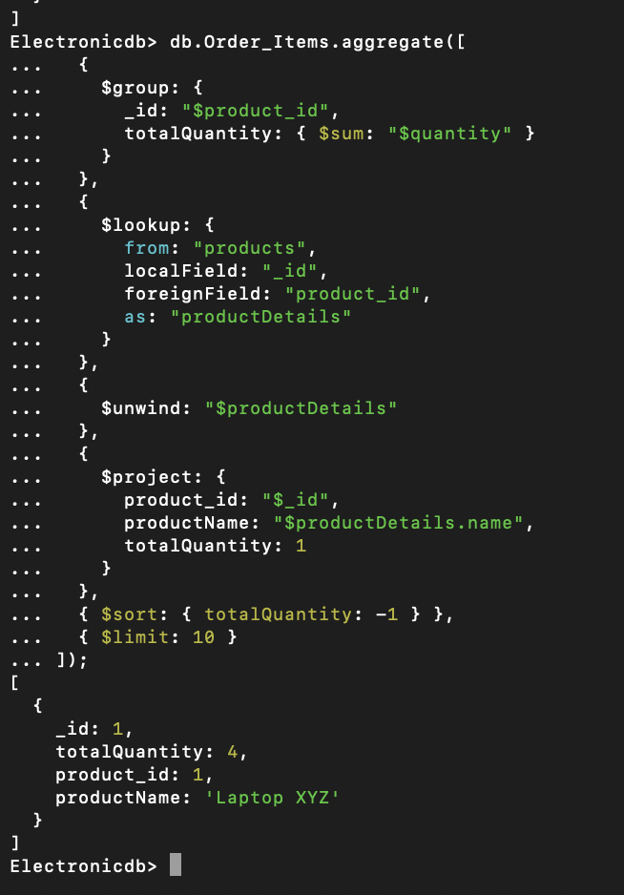 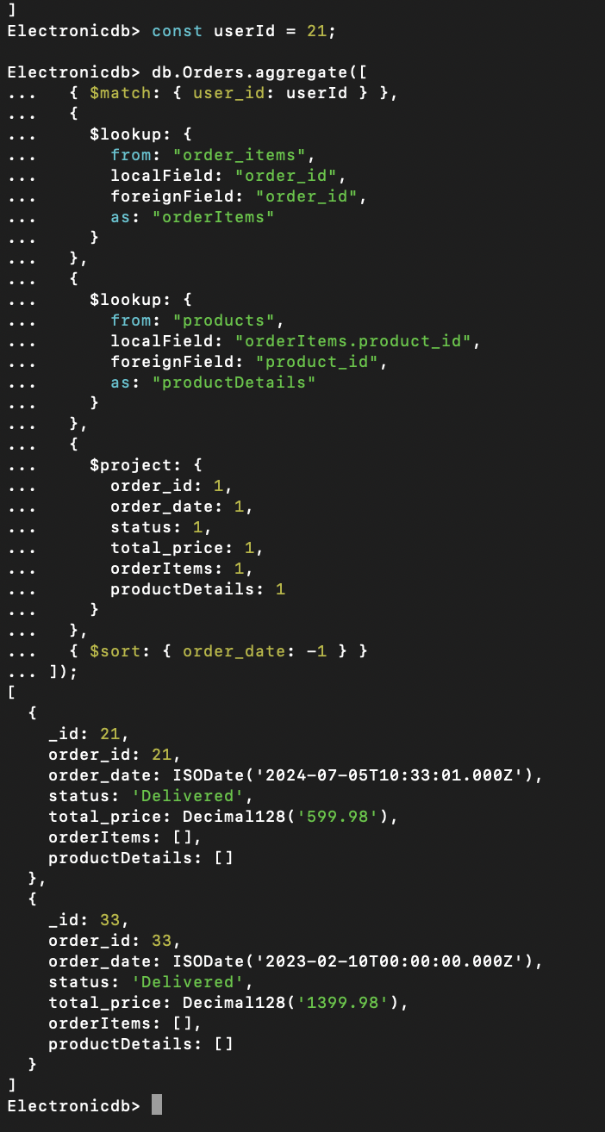

### 6. Average Order Value

Calculate the average order value for all orders.

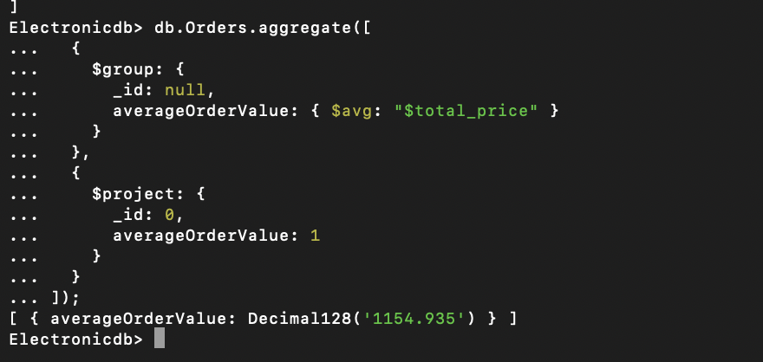

### 7. Inventory Status

Check the current inventory status of all products.

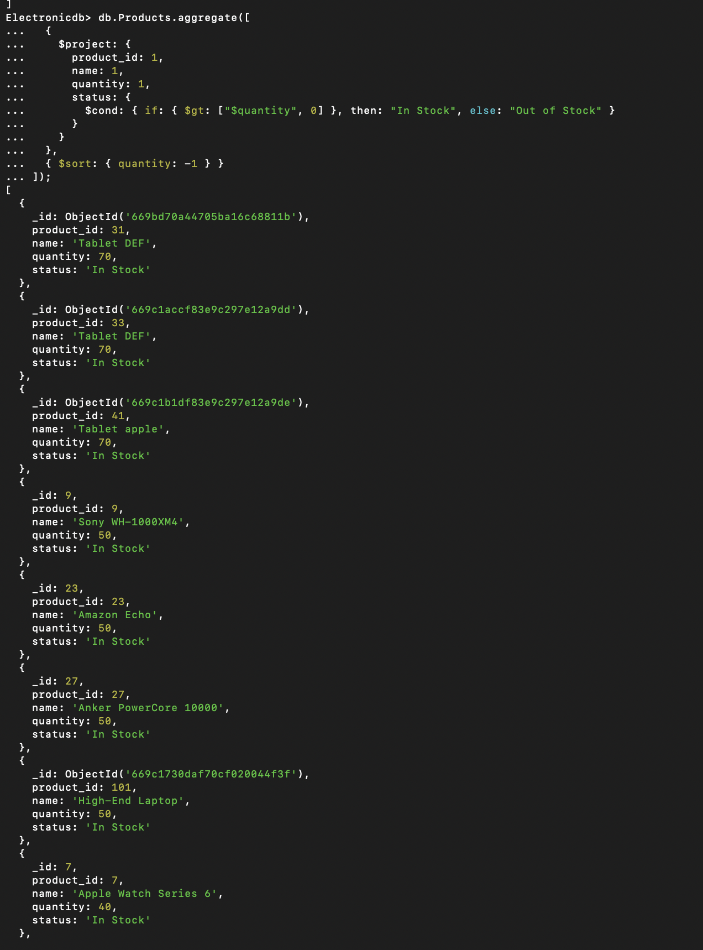

### 8. Revenue by Seller

Calculate the total revenue generated by each seller.

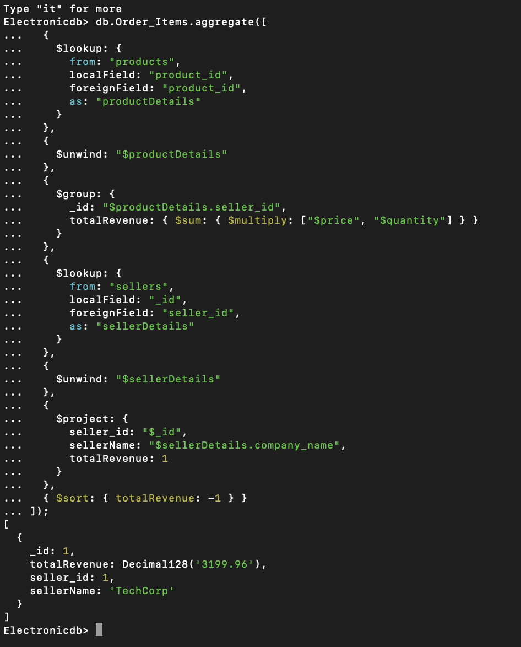

### 9. Customer Segmentation by Purchase Frequency

Segment customers based on their purchase frequency.

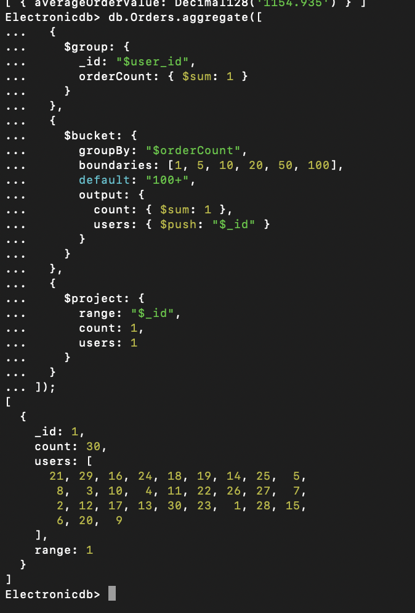

By using MongoDB’s aggregation framework, we performed complex analytical queries to gain valuable insights into your e-commerce data. These queries helped us understand sales performance, customer behavior, inventory status, and more, enabling us to make data-driven decisions to improve your business operations.

# QUERIES USED

#### How many vendors do you have registered?

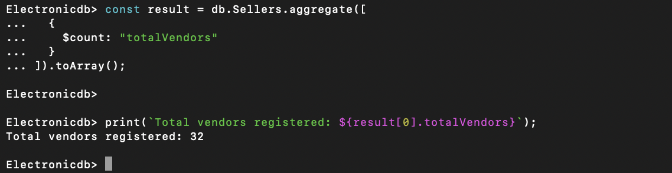

#### How many customers have registered with your platform from the beginning?



#### Who is the vendor with the most number listings?

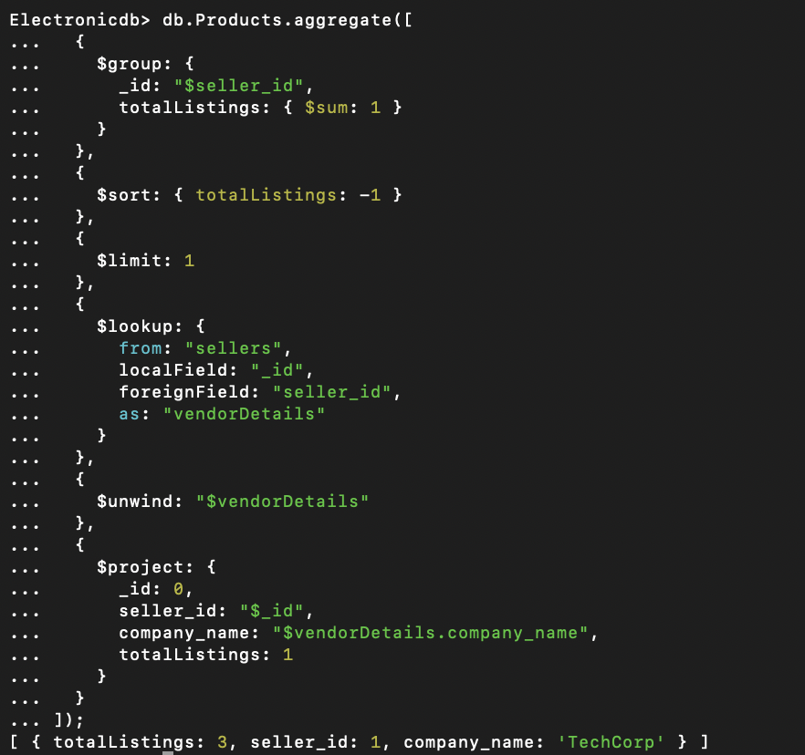

#### Count the Number of Products in a Category

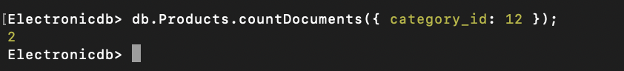

#### Retrieve All Orders for a Specific User

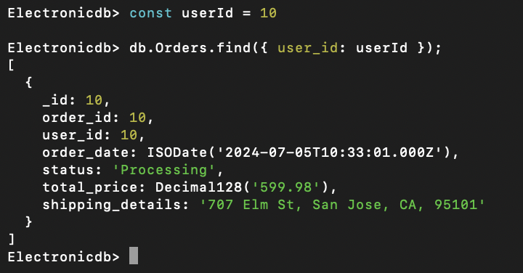

#### Count the Number of Orders Placed This Month

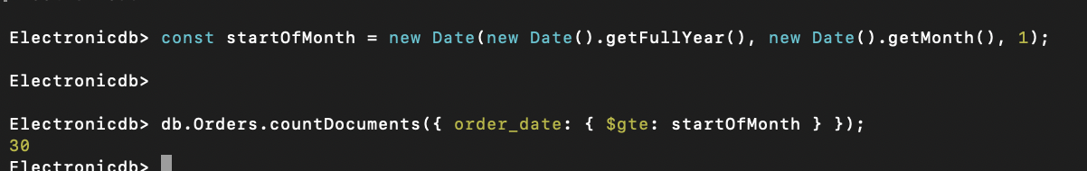

#### Retrieve All Products Sold by a Specific Vendor

#### Retrieve All Reviews for a Specific Product

#### Find the Top 5 Products by Rating

#### Find the Most Recent Orders

These queries provide a range of basic operations that you can perform on your NoSQL database to retrieve, aggregate, and analyze data related to your project. Adjust the field names and collection names as per your actual schema.

# **CONCLUSION**

The transition to a NoSQL database like MongoDB for managing electronic product e-commerce data for our Gadget Galaxy has proven to be a strategic move, offering substantial benefits in terms of scalability, flexibility, and performance. By leveraging MongoDB’s indexing capabilities we achieved significant query performance improvements. The use of the explain function validated that indexes were effectively utilized for range queries, optimizing execution paths and minimizing unnecessary collection scans.

Furthermore, the implementation of various simple and complex NoSQL queries allowed us to extract critical business insights, such as identifying the most expensive orders, calculating total historical spend, and determining the top vendors by revenue. Ensuring data consistency and integrity through schema validation, atomic operations, and transactions further reinforced the reliability of our data. Overall, MongoDB’s robust feature set has enabled us to enhance our data management processes, drive informed decision-making, and improve customer relationships, positioning our e-commerce platform for sustained growth and success.